Description of empirical datasets

ANmodulation
Species: Little owl, Athene noctua
Reference: Linhart, P., & Šálek, M. (2017). The assessment of biases in the acoustic discrimination of individuals. PLOS ONE, 12(5), e0177206. doi:10.1371/journal.pone.0177206
Individual identity: H_{S}=3.39
Number of individuals: 33
Number of calls per individual: 10
Number of acoustic variables: 11
Names of variables and definitions:
These variables were selected to describe the modulation of the fundamental frequency within the call (shape of the call on spectrogram). Also, the duration of the call was measured. Variables were extracted in SASLab Pro by Avisoft.
- id – identity code of each individual; numbers represent individuals from Hungarian subpopulation and four-letter abbreviations represent individuals from Czech subpopulation
- f1, f3, f5, f7, f9, f11, f13, f15, f17, f19 – fundamental frequency at the measuring point (Hertz); In the original study, measurements of fundamental frequency were taken at 20 measuring points (f1-f20) evenly spaced throughout the duration of each call to provide. Eventually, 10 measuring points were considered to be adequate to represent well enough the call frequency modulation. So, every second measuring point from the original 20 measuring points was discarded.
- dur – duration of the call (seconds)
Background information: Calls of little owls were collected in Czech Republic and Hungary. Territorial calls of each male were recorded for three minutes after a short playback provocation (1 min) inside their territories from up to 50 m distance from the individuals. The recordings were made during comparable, favourable meteorological conditions (without strong wind or precipitation), from sunset until midnight between March and April of 2013±2014. This period covered the mating season. The period and the time of the day for recording were selected with regard to the peak in vocal activity of little owls both within a day and within a season.
Original dataset included 54 males with more than 20 calls each (20±41 calls per individual, mean ± SD = 26.9 ± 6.0) with good recording quality.

Histograms for each dataset variable and multivariate Chi-Square Q-Q plot for ANmodulation
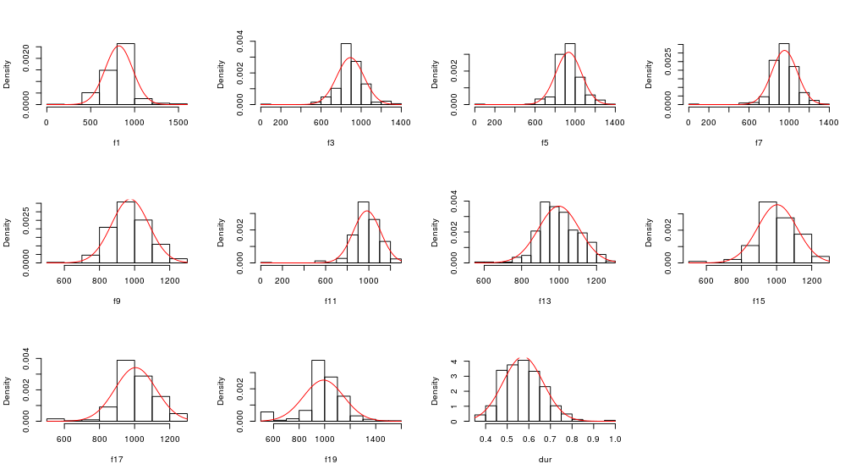
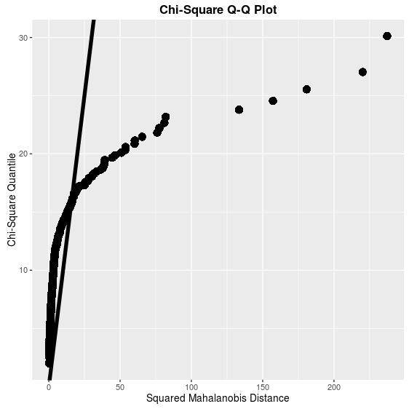

ANspec
Species: Little owl, Athene noctua
Reference: Linhart, P., & Šálek, M. (2017). The assessment of biases in the acoustic discrimination of individuals. PLOS ONE, 12(5), e0177206. doi:10.1371/journal.pone.0177206
Individual identity: H_{S}= 4.61
Number of individuals: 33
Number of calls per individual: 10
Number of acoustic variables: 7
Names of variables and definitions:
These variables were selected to measure basic parameters of call spectrum like the peak frequency, distribution of frequency amplitudes within spectrum, and range of the frequencies (minimum and maximum). Additionally, the duration of the call was measured. Variables were extracted in SASLab Pro by Avisoft.
- id – identity code of each individual; numbers represent individuals from Hungarian subpopulation and four-letter abbreviations represent individuals from Czech subpopulation
- dur – duration of the call (seconds)
- df – frequency of maximum amplitude within the spectrum (Hz); peak frequency
- minf, maxf – minimum and maximum frequency at -25dB relative to the call peak amplitude
- q25, q50, q75 – frequencies at the three quartiles of amplitude distribution; frequencies below which lie 25, 50 and 75% of the energy of the call, respectively (Hz)
Background information: This dataset is based on the same recordings and calls of little owls as in the previous ANmodulation dataset. Same calls were described with different set of parameters.

Histograms for each dataset variable and multivariate Chi-Square Q-Q plot for ANspec
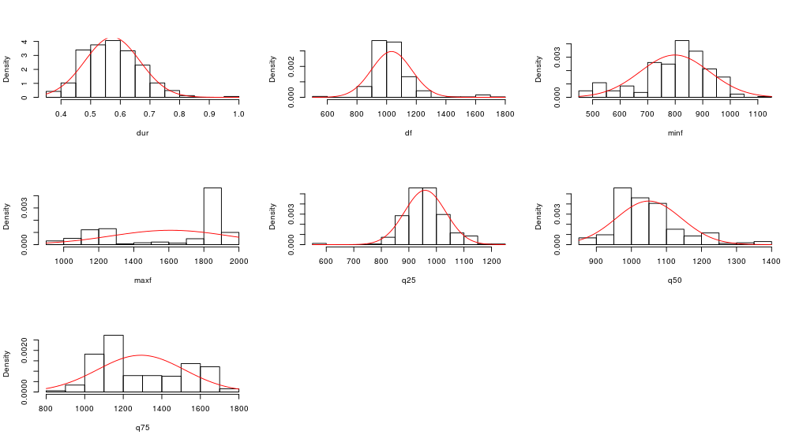
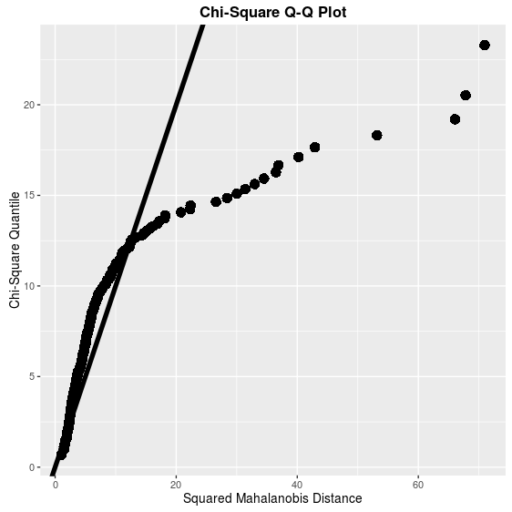

CCformants
Species: Corncrake, Crex crex
Reference: Budka, M., & Osiejuk, T. S. (2013). Formant Frequencies are Acoustic Cues to Caller Discrimination and are a Weak Indicator of the Body Size of Corncrake Males. Ethology, 119, 960–969. doi:10.1111/eth.12141
Individual identity: H_{S}= 10.52
Number of individuals: 33
Number of calls per individual: 10
Number of acoustic variables: 4
Names of variables and definitions:
Formants (second to fifth) were measured within the first syllable of the call. Formants were extracted by PRAAT.
- id – identity code of each individual
- s1f2, s1f3, s1f4, s1f5 – formants 2 to 5, respectively, measured within the first syllable of the call
Background information: Corncrake calls were recorded at three sites in Poland and one in the Czech Republic Recordings were made during the corncrake breeding season, from 8 to 30 July, in 2011 and in 2012. Males were recorded when calling spontaneously, in favourable conditions, at night (from 22.00 to 03.30, local time) from a distance of ca. 5–10 m.
The original dataset comprised 104 males with 10 calls measured from each male.

Histograms for each dataset variable and multivariate Chi-Square Q-Q plot for CCformants
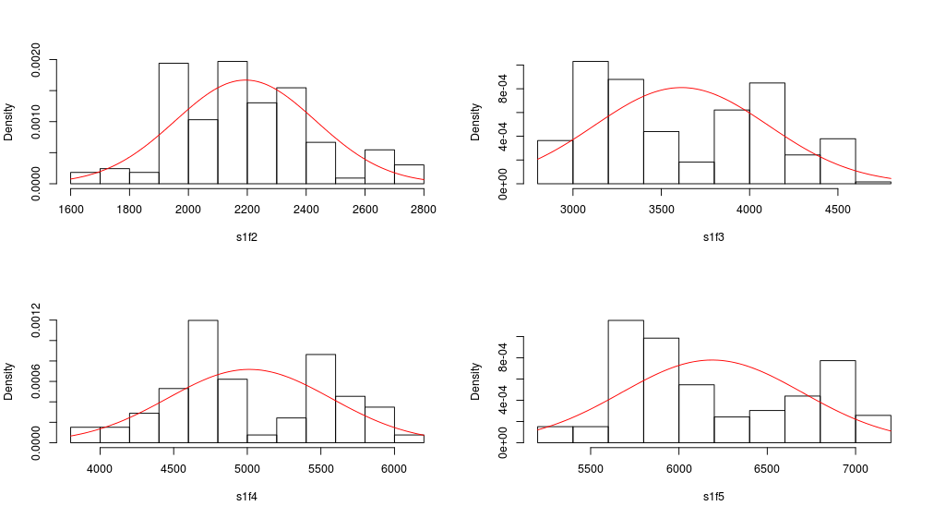
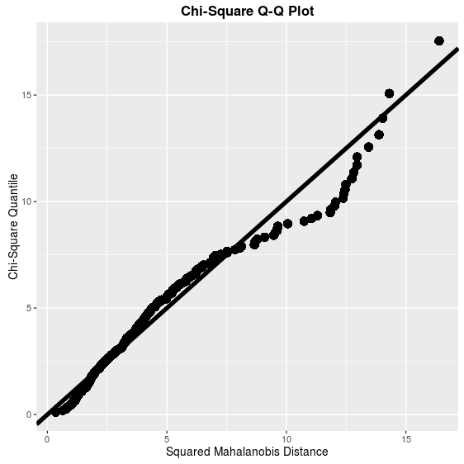

CCspec
Species: Corncrake, Crex crex
Reference: Budka, M., & Osiejuk, T. S. (2013). Formant Frequencies are Acoustic Cues to Caller Discrimination and are a Weak Indicator of the Body Size of Corncrake Males. Ethology, 119, 960–969. doi:10.1111/eth.12141
Individual identity: H_{S}= 5.15
Number of individuals: 33
Number of calls per individual: 10
Number of acoustic variables: 7
Names of variables and definitions:
These variables were selected to measure basic spectral parameters of each first syllable of the call like the peak frequency, distribution of frequency amplitudes within spectrum, and range of the frequencies (minimum and maximum). Additionally, the duration of the call was measured. Variables were extracted in SASLab Pro by Avisoft.
- id – identity code of each individual
- dur – duration of the first syllable (seconds)
- df – frequency of maximum amplitude within the spectrum (Hz); peak frequency
- minf, maxf –minimum and maximum frequency at -25dB relative to the call peak amplitude
- q25, q50, q75 – frequencies at the three quartiles of amplitude distribution; frequencies below which lie 25, 50 and 75% of the energy of the call, respectively (Hz)

Background information: This dataset is based on the same recordings and calls of corncrakes as in the previous CCspec dataset. Same calls were described with different set of parameters.

Histograms for each dataset variable and multivariate Chi-Square Q-Q plot for CCspec
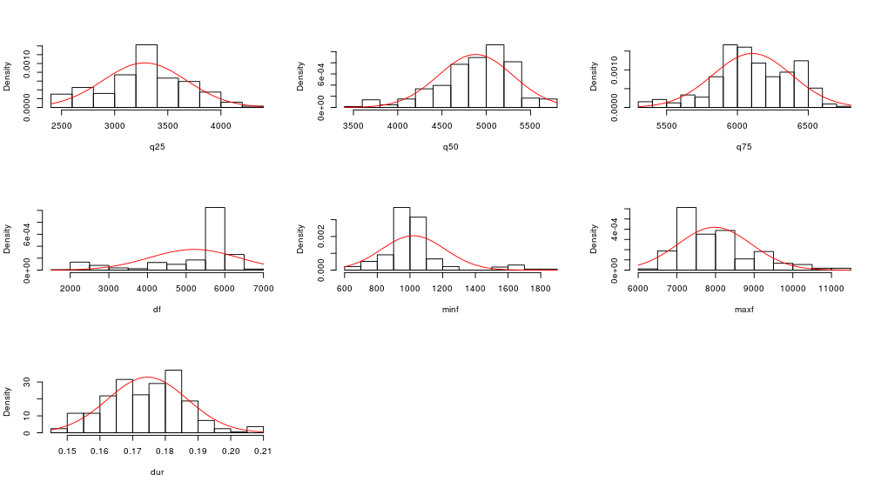
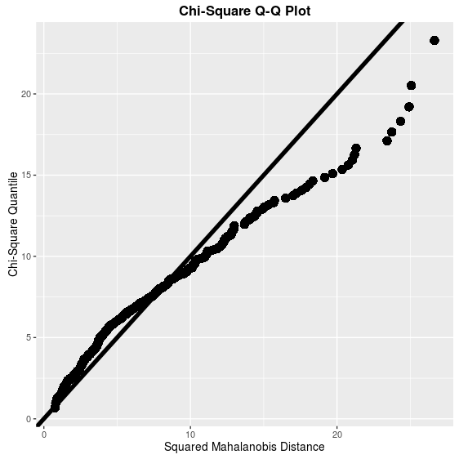

LAhighweewoo
Species: Yellow-breasted boubou, Laniarius atroflavus
Reference: Osiejuk, unpublished data
Individual identity: H_{S}= 3.57
Number of individuals: 33
Number of calls per individual: 10
Number of acoustic variables: 7
Names of variables and definitions:
These variables were selected to measure basic spectral parameters of each “high weewoo” call like the peak frequency, distribution of frequency amplitudes within spectrum, and range of the frequencies (minimum and maximum). Additionally, the duration of the call was measured. Variables were extracted in Raven Pro 1.5 by the Cornell Bioacoustic Research Program.
- id – identity code of each individual
- dur – duration of the first syllable (seconds)
- df – frequency of maximum amplitude within the spectrum (Hz); peak frequency
- minf, maxf –minimum and maximum frequency at -25dB relative to the call peak amplitude
- bandw – bandwidth of the call (Hz); difference between maxf and minf
- q25, q75 – frequencies at the two quartiles of amplitude distribution; frequencies below which lie 25 and 75% of the energy of the call, respectively (Hz)
Background information:
Male Yellow-breasted boubous were recorded in Bamenda region in Cameroon. Birds were recorded between 06.00 to 10.00 in the morning in 2016, typically, from the distance of 10 - 20 meters. The calls were recorded after short provocation with playback. Repertoire of males at the field site included three distinct call types and only the most common call typed labeled as “High wee woo” was used for this study.
The original dataset comprised 33 individuals and 10 calls per individual.

Histograms for each dataset variable and multivariate Chi-Square Q-Q plot for LAhighweewoo
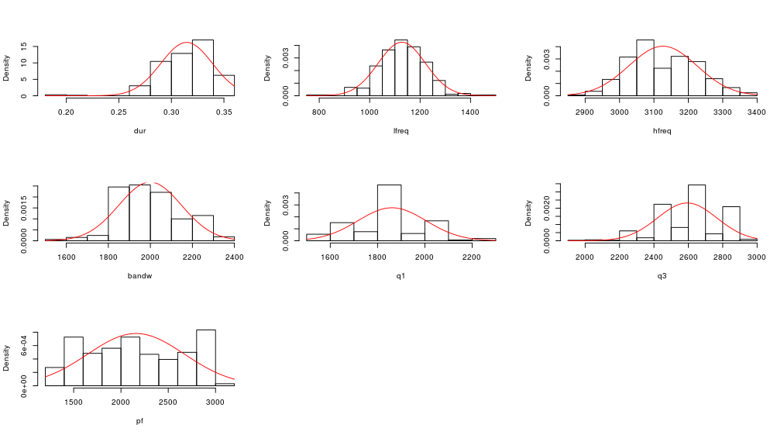
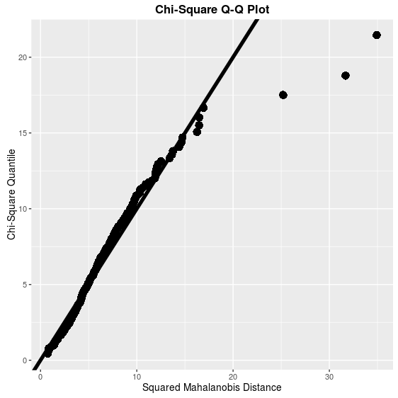

SSgrunts
Species: Domestic pig, Sus scrofa domestica
Reference: Syrová, M., Policht, R., Linhart, P., & Špinka, M. (2017). Ontogeny of individual and litter identity signaling in grunts of piglets. The Journal of the Acoustical Society of America, 142(5), 3116–3121. doi:10.1121/1.5010330
Individual identity: H_{S} = 2.57
Number of individuals: 33
Number of calls per individual: 10
Number of acoustic variables: 10
Names of variables and definitions:
These variables were selected to be the most informative regarding the individual identity by the reference study. Variables were extracted using the LMA 2008 software for analysis of animal sounds by Kurt Hammerschmidt.
- id – identity code of each individual
- fp1amean – mean amplitude of the 1st frequency peak (relative amplitude)
- q1mean – mean frequency of the 1st DFreqA (Hz); equivalent to q25 in ANspec, CCspec, and LAhighweewoo
- csmean – mean correlation coefficient of successive time segments
- tonalF0 – estimation of segments with detectable fundamental frequency (%)
- q3mean – mean frequency of the 3nd DFreqA (Hz); equivalent to q75 in ANspec, CCspec, and LAhighweewoo
- noise - % of noise time segments
- ranmean – mean frequency range (Hz)
- q2mean – mean frequency of the 2nd DFreqA (Hz); equivalent to q50 in ANspec, CCspec, and LAhighweewoo
- df2pr – % of time segments where 2nd DomFreqB detected
- q2min – min frequency of the 2nd DFreqA (Hz)
Background information: Piglets were recorded in 2014 and 2015 at the research farm of Institute of Animal Science in Prague. To elicit the calls piglets were separated from the litter and sow and were recorded in social isolation in age of 25-30 days after birth from the distance of 1m. Piglets were recorded opportunistically during the day.
The original dataset comprised 97 piglets coming from 13 different litters and 10 calls per individual piglet.

Histograms for each dataset variable and multivariate Chi-Square Q-Q plot for SSgrunts
