Relationship between H_{S} variants and PIC variants
PIC_{betweentot}, PIC_{betweenmeans}, and 2^ H_{Snpergroup} are almost identical metrics as revealed by high linear correlations between them (R²(PIC_{betweentot} vs. PIC_{betweenmeans}) = 0.996; R²(PIC_{betweenmeans} vs. 2^H_{Snpergroup}) = 0.997; R²(PIC_{betweentot} vs. 2^H_{Snpergroup}) = 0.997). However, they differ in small important details. If there is essentially no individual variability in the data (individuality = 0.01), H_{Snpergroup} correctly gives values around 0 (mean ± sd = 0.00 ± 0.05) while both PICs converge to higher values (PIC_{betweentot} mean ± sd = 1.01 ± 0.05; PIC_{betweenmeans} mean ± sd = 0.32 ± 0.13) (see Figure S4.1 below).
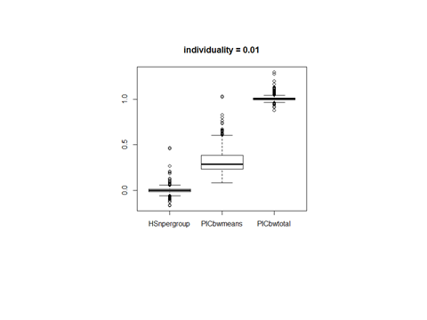
Metric Value
H_{Snpergroup} PIC_{betweenmeans} PIC_{betweentot}
Figure S4.1. Values of H_{Snpergroup}, PIC_{betweenmeans}, and PIC_{betweentot} for 0 individuality in data.

H_{Snpergroup} and H_{Svarcomp} were both independent of sampling but their absolute values were different. Interestingly, H_{Svarcomp} was identical to 2 * H_{Snpergroup} (linear regression: R2 = 1, intercept = 0.01, beta = 1.99).

