Three-dimensional models of coral microatolls using structure-from-motion photogrammetry and iPhone LiDAR scanning: A fast, reproducible method for collecting relative sea-level data in the field

Nurul Syafiqah Tan, Rohan Gautam, Fangyi Tan, Gina M. Sarkawi, Jędrzej M. Majewski,
Junki Komori, Shi Jun Wee, Khai Ken Leoh, Lucas D. Koh, Adam D. Switzer, Aron J. Meltzner

Supporting Information

S1 Reconstructing relative sea level with coral microatolls slabs

Coral microatoll slabs can provide detailed reconstructions of past relative sea-level (RSL) changes by revealing the coral’s annual banding in cross section and thus the coral’s growth history. However, the reconstruction of a coral’s cross-section profile from a slab typically involves a series of steps, from the physical slabbing of the coral to alignment; further slicing and performing X-radiography (X-rays) on the coral; and mosaicking of the X-ray images (Meltzner & Woodroffe, 2015). Errors could be introduced during the restoration of the slab to original horizontality (Zachariasen et al., 2000).

Slabbing is the process of extracting a vertical cross section through a chosen radius or diameter of the coral. Before the slab is extracted, slab screws are installed at intervals along the selected radius, marking the location of the future slab. These screws are precisely surveyed, typically with a total station. After the slab has been extracted, with the fragments reassembled using epoxy (Fig.S1), a line of original horizontality (LOH) is drawn onto the physical slab. The purpose of the LOH is to link the slab’s elevation to the surveyed reference frame of the entire site and to preserve information about the slab’s original horizontality. By using the surveyed elevation of each slab screw, a researcher projects downwards from each screw to a fixed arbitrary elevation; the LOH is delineated, representing the original horizontal when the coral was observed in situ. Subsequently, small holes are drilled along the LOH to facilitate the identification of the LOH on an X-rayed slab (e.g. Zachariasen et al., 2000; Natawidjaja et al., 2006; Meltzner & Woodroffe, 2015). Uncertainties from the slabbing process can arise during various steps. For instance, the slab face may not be perfectly vertical; the holes drilled to mark the LOH may not be perfectly orthogonal to the slab face; and reassembling fragmented sections can lead to imperfect alignment. Additionally, slabs are typically subdivided into thinner physical slices (not to be confused with slices generated from 3D models) for X-ray imaging, which can result in slight differences in structures preserved from one slice to another.

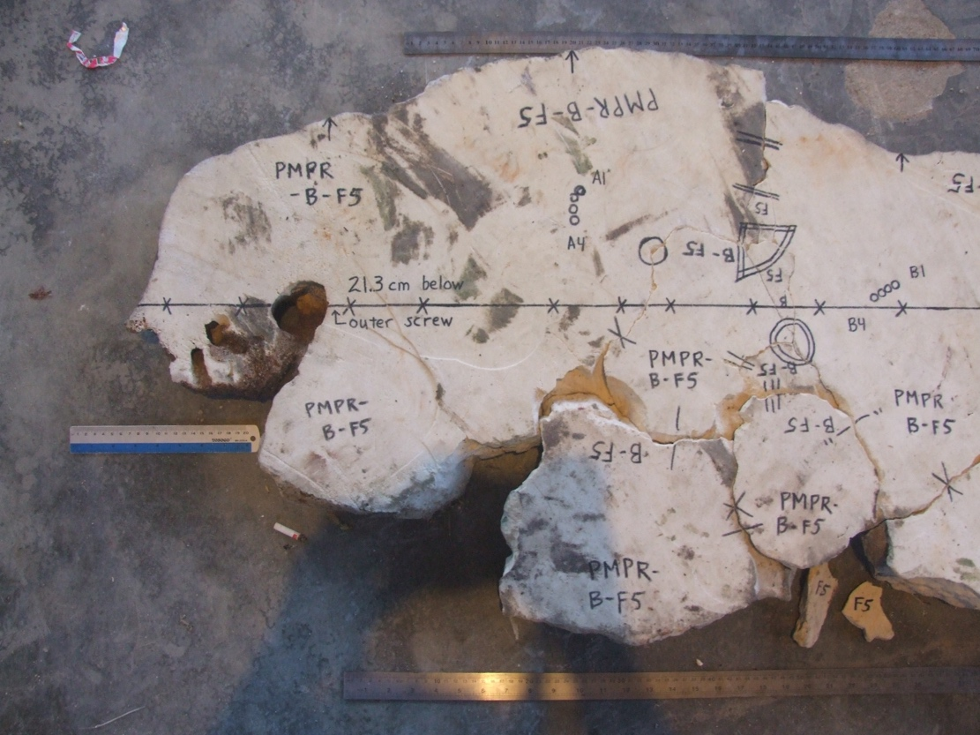
Fig.S1: Outermost portion of the slab extracted from PMPR-B-F5. During the process of slabbing, the slab broke into fragments, which were subsequently epoxied together before analysis. This photo shows the drawing of the line of original horizontality, projected 21.3 cm below the outermost slab screw.

S2 Removing material on the coral prior to data acquisition

On the dead upper surface of a coral microatoll, a mixture of sediment, boring mollusks and/or plant growth tends to accumulate (Goreau et al., 1979; Flora and Ely, 2003; Lozano-Cortés and Zapata, 2014) (Fig.S2), where such material can raise the apparent coral surface elevation, obscuring important features of the surface morphology. Removing this material prior to data acquisition is crucial as it allows for improved resolution of subtle features on the coral that will be critical for interpretation of coral morphology.

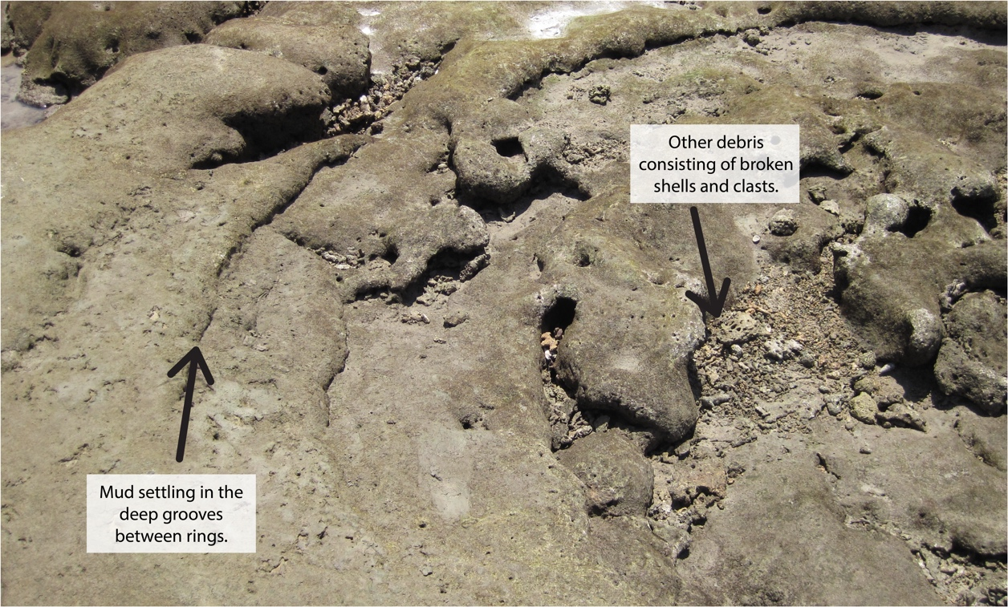
Fig. S2: Example of the accumulation of sediments and shells on the uncleaned surface of PMPR-B-F3, imaged in the creation of the 3D model.

S3 Structure-from-motion (SfM) photogrammetry

The following details the methods necessary for SfM of coral microatolls. This technique can be broadly divided into data acquisition and data processing.

S3.1 SfM photogrammetry: Data acquisition

The quality of the photos taken is important as it directly influences the quality of the resultant model (Mosbrucker et al., 2017; Leduc et al., 2019). While in the field, the photos need to be of different perspectives of the coral microatoll; they should be taken from different angles, different heights, and different distances from the coral (Fig.2A). Each successive photo should have a substantial overlap with the previous one, with an ideal overlap of 70-80% (Lange and Perry, 2020; Kasprzak et al., 2018). A high image overlap is key to finding tie points between two or more images. Generally, the greater the number of tie points, the higher the quality of the resulting model (Eltner et al., 2016). While photographing the coral, it is important to refrain from the use of wide-angle lenses or telephoto (zoom) functions. These can negatively affect how the software assesses the perspective of the photo during the processing stage (Mosbrucker et al., 2017).

S3.2 SfM photogrammetry: Data processing

Agisoft Metashape follows the same workflow and has the same outputs as other structure-from-motion multi-view stereo (SfM-MVS) software, with the only notable difference being that it has its own set of custom algorithms (Mali and Kuiry, 2018). At the time of writing, there has been no official documentation that extensively describes these algorithms. We generally follow the workflow outlined by Iglhaut et al. (2019) and Mali and Kuiry (2018) and advise readers to check these studies for further details of the algorithms.

After adding the photos into the workspace, the first step of this automated workflow involves photo alignment to generate a sparse point cloud. A point cloud refers to a quantity of points with 3D coordinates describing the surface (Eltner et al., 2016), with each point having a numerical descriptor in space. This step extracts key points and tie points from the photographs (Iglhaut et al., 2019), where the sparse point cloud is a representation of the position of key points and tie points matched across the various images (Iglhaut et al., 2019; Mali et al., 2021).

In the second step, information from the sparse point cloud is integrated with data derived from the input images to produce a dense point cloud (Iglhaut et al., 2019). Unlike a sparse point cloud, a dense point cloud portrays a more continuous surface and is a representation of a depth map. When prompted to select a depth filtering mode, it is crucial to use mild depth filtering as this option is best for coral microatolls which have small, important details that would ideally be preserved in the model.

The third step involves the creation of a polygonal mesh. A polygonal mesh is composed of vertices, edges and faces that define the shape of the reconstructed object (Catalucci et al., 2018; Park and Lee, 2019). To make the final mesh photorealistic, texture is overlaid by blending the source photos to create a texture atlas. The mesh can then be further processed into other forms, such as a 2.5D digital elevation model (DEM), which represents the model's surface in a regular grid format with height values assigned to each cell (Agisoft LLC, 2021), and an orthomosaic, a seamless composite created by merging the source images into a single high-resolution image (Agisoft LLC, 2021).

To ensure the model is positioned within a real-world coordinate system, the final step is to georeference the model using ground control points (GCPs) surveyed in the field. After locating the unique points in the photorealistic mesh and inputting their respective surveyed coordinates, the scaled and georeferenced model is ready for export and further analysis.

A summarized workflow of the data processing steps for SfM photogrammetry via Agisoft Metashape Professional is detailed in Table S1. The steps taken were adopted in this study. However, we recommend that users explore different settings for their own situation, i.e. the size of the coral and the level of detail preserved on the coral surface.

Table S1: Guided workflow: creating a 3D model using SfM photogrammetry in Agisoft Metashape Professional
Step | Workflow | Purpose | Actions and/or settings
1 | Add Photos | Loads photos into the software. | Visually inspect the photos to ensure their orientation is consistent (e.g. horizontal) and their quality is satisfactory. Unwanted photos can be removed by right clicking them and selecting ‘Remove’ or ‘Disable’. Unnecessary objects captured in the images (e.g. bags, shoes) can be masked to reduce noise.
2 | Align Photos | Estimates the camera’s position and orientation, and build a sparse point cloud. | High accuracy, enable generic and reference preselection from the source data. Disable ‘Reset current alignment’. Key and tie point limits are set to 40,000 and 4000, respectively. Apply masks to adaptive camera model fitting.
3 | Build Dense Cloud | Creates a depth map which portrays a more continuous surface of the microatoll. | Medium or high quality with mild depth filtering, calculate point colours.
4 | Build Mesh | Defines the shape of the model. | Sourced from dense point cloud, with an arbitrary (3D) surface type and a high face count. Enable default interpolation to fill any gaps in the final model, ensuring a smooth and continuous surface.
5 | Build Texture | Applies images onto the model to resemble the actual object. | Sourced from images, with a mosaic blending mode and a texture count of 8000. Enable hole filling and ghosting filter.
6 | Reference – Georeferencing | References the model to a local coordinate system relative to the total station and scales it accurately. | In the reference panel, uncheck all cameras and markers and ensure that only the ground control points are checked. Input the easting, northing and elevation (m) for the survey points. It should exclude EXIF data, which are GPS coordinates embedded in the images with meter-scale precision.
7 | Build DSM | Generates a georeferenced digital surface model of the microatoll. | Use a local coordinate system (from the total station), sourced from the dense point cloud. Enable interpolation. Export as a TIFF file.
8 | Build orthomosaic | Generates a top-down, distortion-free image of the microatoll by seamlessly merging the images used. | Using geographic projection, select the DEM as the source data for orthomosaic creation. Enable hole filling. Export as a TIFF file.

S4 iPhone LiDAR

S4.1 iPhone LiDAR: Data acquisition

Several applications are presently available for creating iPhone LiDAR scans, including 3D Scanner AppTM and Polycam 3D Scanner. For this study, we utilized the Scaniverse app, developed by Niantic and initially released in 2021. Before starting the scan, the user sets the range, which should depend on the size of the coral microatoll. The range can also be manually adjusted during the scanning process. The scan is then performed by walking around the coral with the hand-held iPhone or iPad, ensuring the capture of imagery from every angle (Fig.2B) (Luetzenburg et al., 2021). The user is advised to experiment with different scan durations and speed of camera movement in the field.

The application provides a real-time window showing the progress of the scan; areas still delineated with red stripes indicate sections that remain to be scanned. While not every red stripe needs to be removed, as 'Scaniverse' can interpolate to fill small gaps, users should still ensure that stripes are cleared from areas of the coral intended to be preserved in the final reconstructed model. After the scan is done, the user should select ‘Detailed Mode’ as the processing mode. This mode is ideal for smaller scenes with substantial texture, such as coral microatolls, as it combines photogrammetric tools to enhance the final model’s quality, coverage, and completeness. Since iPhone LiDAR scans also capture texture from the RGB camera (Järvenpää, 2021; Luetzenburg et al., 2021; Tavani et al., 2022), the final output is a photo-realistic mesh, which can be further sampled to create a point cloud. Both outputs can be exported for further data processing.

S4.2 iPhone LiDAR: Data processing

After the raw LiDAR scan has been taken in the field with the Scaniverse app, data processing is done on CloudCompare, an open-source software that is ideally suited for working with raw point clouds due to its extensive set of tools designed for such data. However, the initial point cloud from the scan is not usable; it lacks the density necessary to accurately pinpoint GCPs with high certainty in subsequent steps. This limitation, which has also been pointed out by Luetzenburg et al. (2021) and Tavani et al. (2022), can be addressed by sampling the mesh from the iPhone LiDAR scan to create a mesh-derived point cloud. This process, performed in CloudCompare using the “sample points on a mesh” tool, allows us to control the density of the secondary point cloud based on the size of the coral microatoll. The underlying algorithm incorporates a relatively straightforward random sampling method, modified from Turk (1990). It iterates through each triangle that makes up the mesh. Based on the user-defined point cloud density, the algorithm determines the number of points to be sampled on each triangle. The simplicity of this algorithm allows for this process to be computationally efficient.

The primary benefit of this process is the creation of a denser point cloud, which facilitates the subsequent steps in the workflow (Table S2). However, the risk of resampling is the potential loss of original data and the introduction of artefacts that may inaccurately represent the model surface (Lebrat et al., 2021).

A summarised workflow of the data processing steps for iPhone LiDAR via CloudCompare is detailed in Table S2.

Table S2: Guided workflow: creating a 3D model using iPhone LiDAR in CloudCompare
Step | Workflow | Purpose | Actions and/or settings
1 | Add model | Loads model into CloudCompare. |   File > Open  Add the mesh model from the iPhone LiDAR scan in OBJ format into the DB tree. Ensure that the associated JPG and MTL files are placed in the same folder as the OBJ file. This will ensure the imported mesh looks photo-realistic.
2 | Segmenting out non-coral-microatoll parts from the model | Removes non-coral-microatoll parts such as sandy substrate from the model. |   Edit > Segment  Use the ‘Segment’ tool to remove non-crucial parts. Click on the 'Segment in' 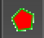 option to finish this step. In the DB tree, the imported mesh model will be separated into 'remaining' (non-coral parts) and 'part' (coral).
3 | Sampling points from the mesh | Since the raw point cloud from the scan is not dense enough to notice subtle features in the coral microatoll such as the reference screw, we use a mesh-derived point cloud for subsequent processing steps. |   Edit > Mesh > Sample Points  While selecting the segmented mesh, use the ‘Sample Points’ tool to derive a point cloud. The density/number of points of the final point cloud should depend on the size of the coral microatoll (e.g. 1 million points). This mesh-sampled point cloud will be our final desired point cloud.
4a | Reference – Georeferencing | The model is referenced to a local coordinate system relative to the total station and scaled accurately. | Edit > Mesh > Sample Points  Repeat step (3) to create another mesh-sampled point cloud, albeit with a significantly reduced density (e.g. 1000 points). This mesh-sampled point cloud will not affect our final output. In the DB tree, rename both sampled point clouds to avoid confusion in subsequent steps.
4b | Reference – Georeferencing |  | 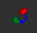  Tools > Registration > Align (point pairs picking)  While selecting both mesh-sampled point clouds from the DB tree, use the ‘Align (point pair picking)’. Designate the denser cloud as the 'aligned' one, and the less dense cloud as the 'reference'.  Using the point pairs picking tool, identify the GCPs on the coral. Remember the order in which the points were selected. The selected points will appear in the upper box (Fig.S3A) as A0, A1, etc.  Once point selection is complete, click the pencil icon in the lower box (Fig.S3B) and input the surveyed easting, northing and elevation (m) for each point, ensuring the order of the points is maintained.  Finally, click "Align" followed by the tick symbol. The denser point cloud is georeferenced and scaled. The less dense point cloud can now be removed from the DB tree.
5 | Build DEM | Generates a georeferenced digital elevation model of the microatoll. |   Tools > Projection > Rasterize (and contour plot)  From the georeferenced point cloud, use the ‘Rasterise’ tool to convert the 3D point cloud into a 2.5D DEM, using the settings as shown in Fig.S3C. Click on 'Update grid', before selecting 'Raster' to save the DEM to a TIFF file.
6 | Exporting geo-referenced point cloud | Export for further analysis with other processing software. |   File > Save  Select the geo-referenced point cloud from the DB tree and click 'Save'.

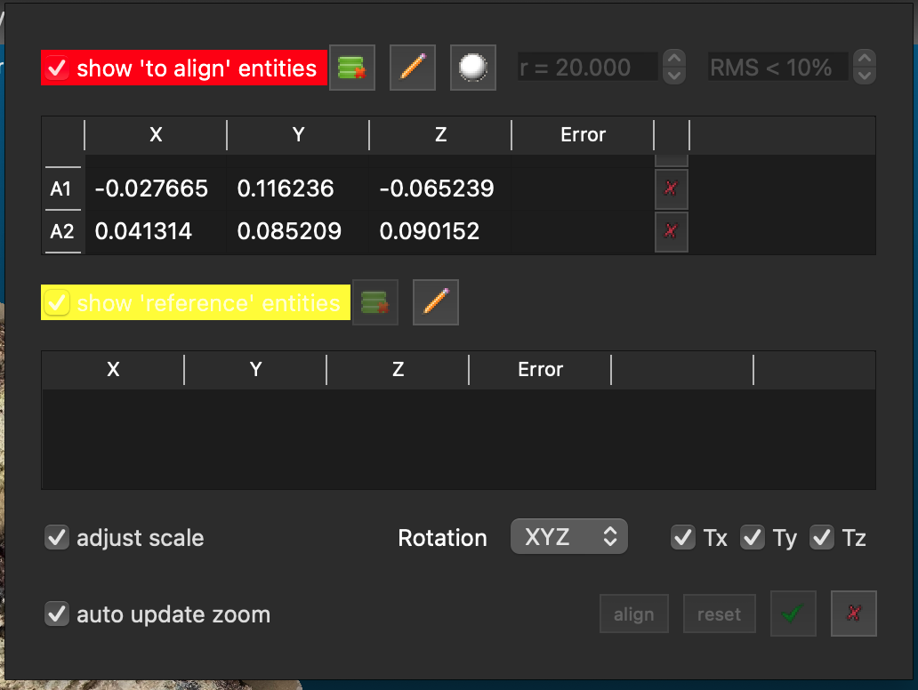 | Fig.S3A: The window that appears when the Align (point pairs picking) tool is selected. When initially selecting the GCPs on the coral, keeping in mind the order of the points; they will appear as A0, A1, etc. in the upper box.
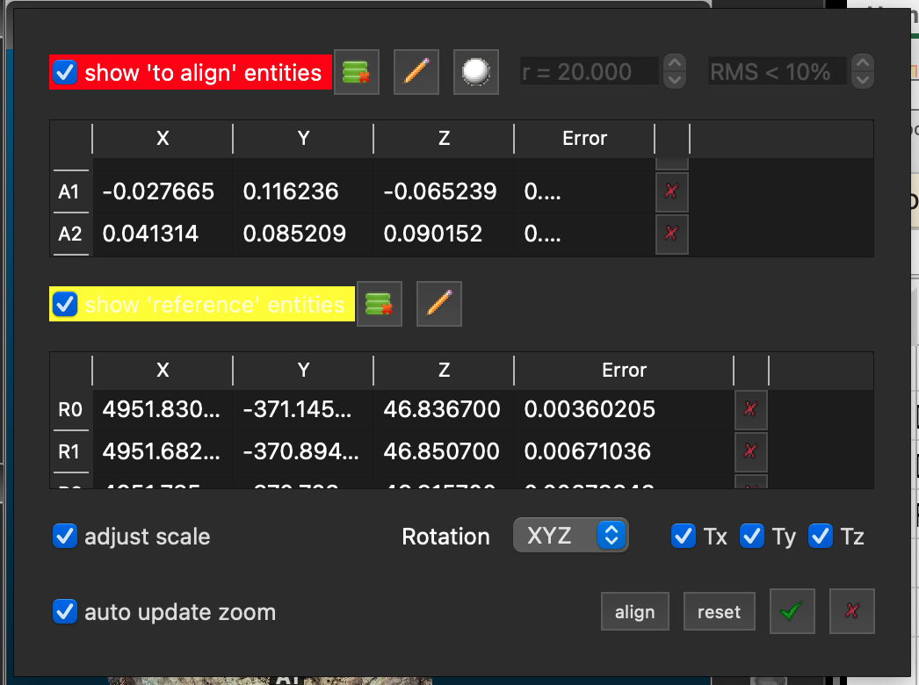 | Fig.S3B: Once all the GCPs are selected as A_{x} points, click on the bottom pencil icon to input the surveyed coordinates of the GCPs to georeference the point cloud. Finally, click the 'Align' button and the tick to complete the geoferencing.
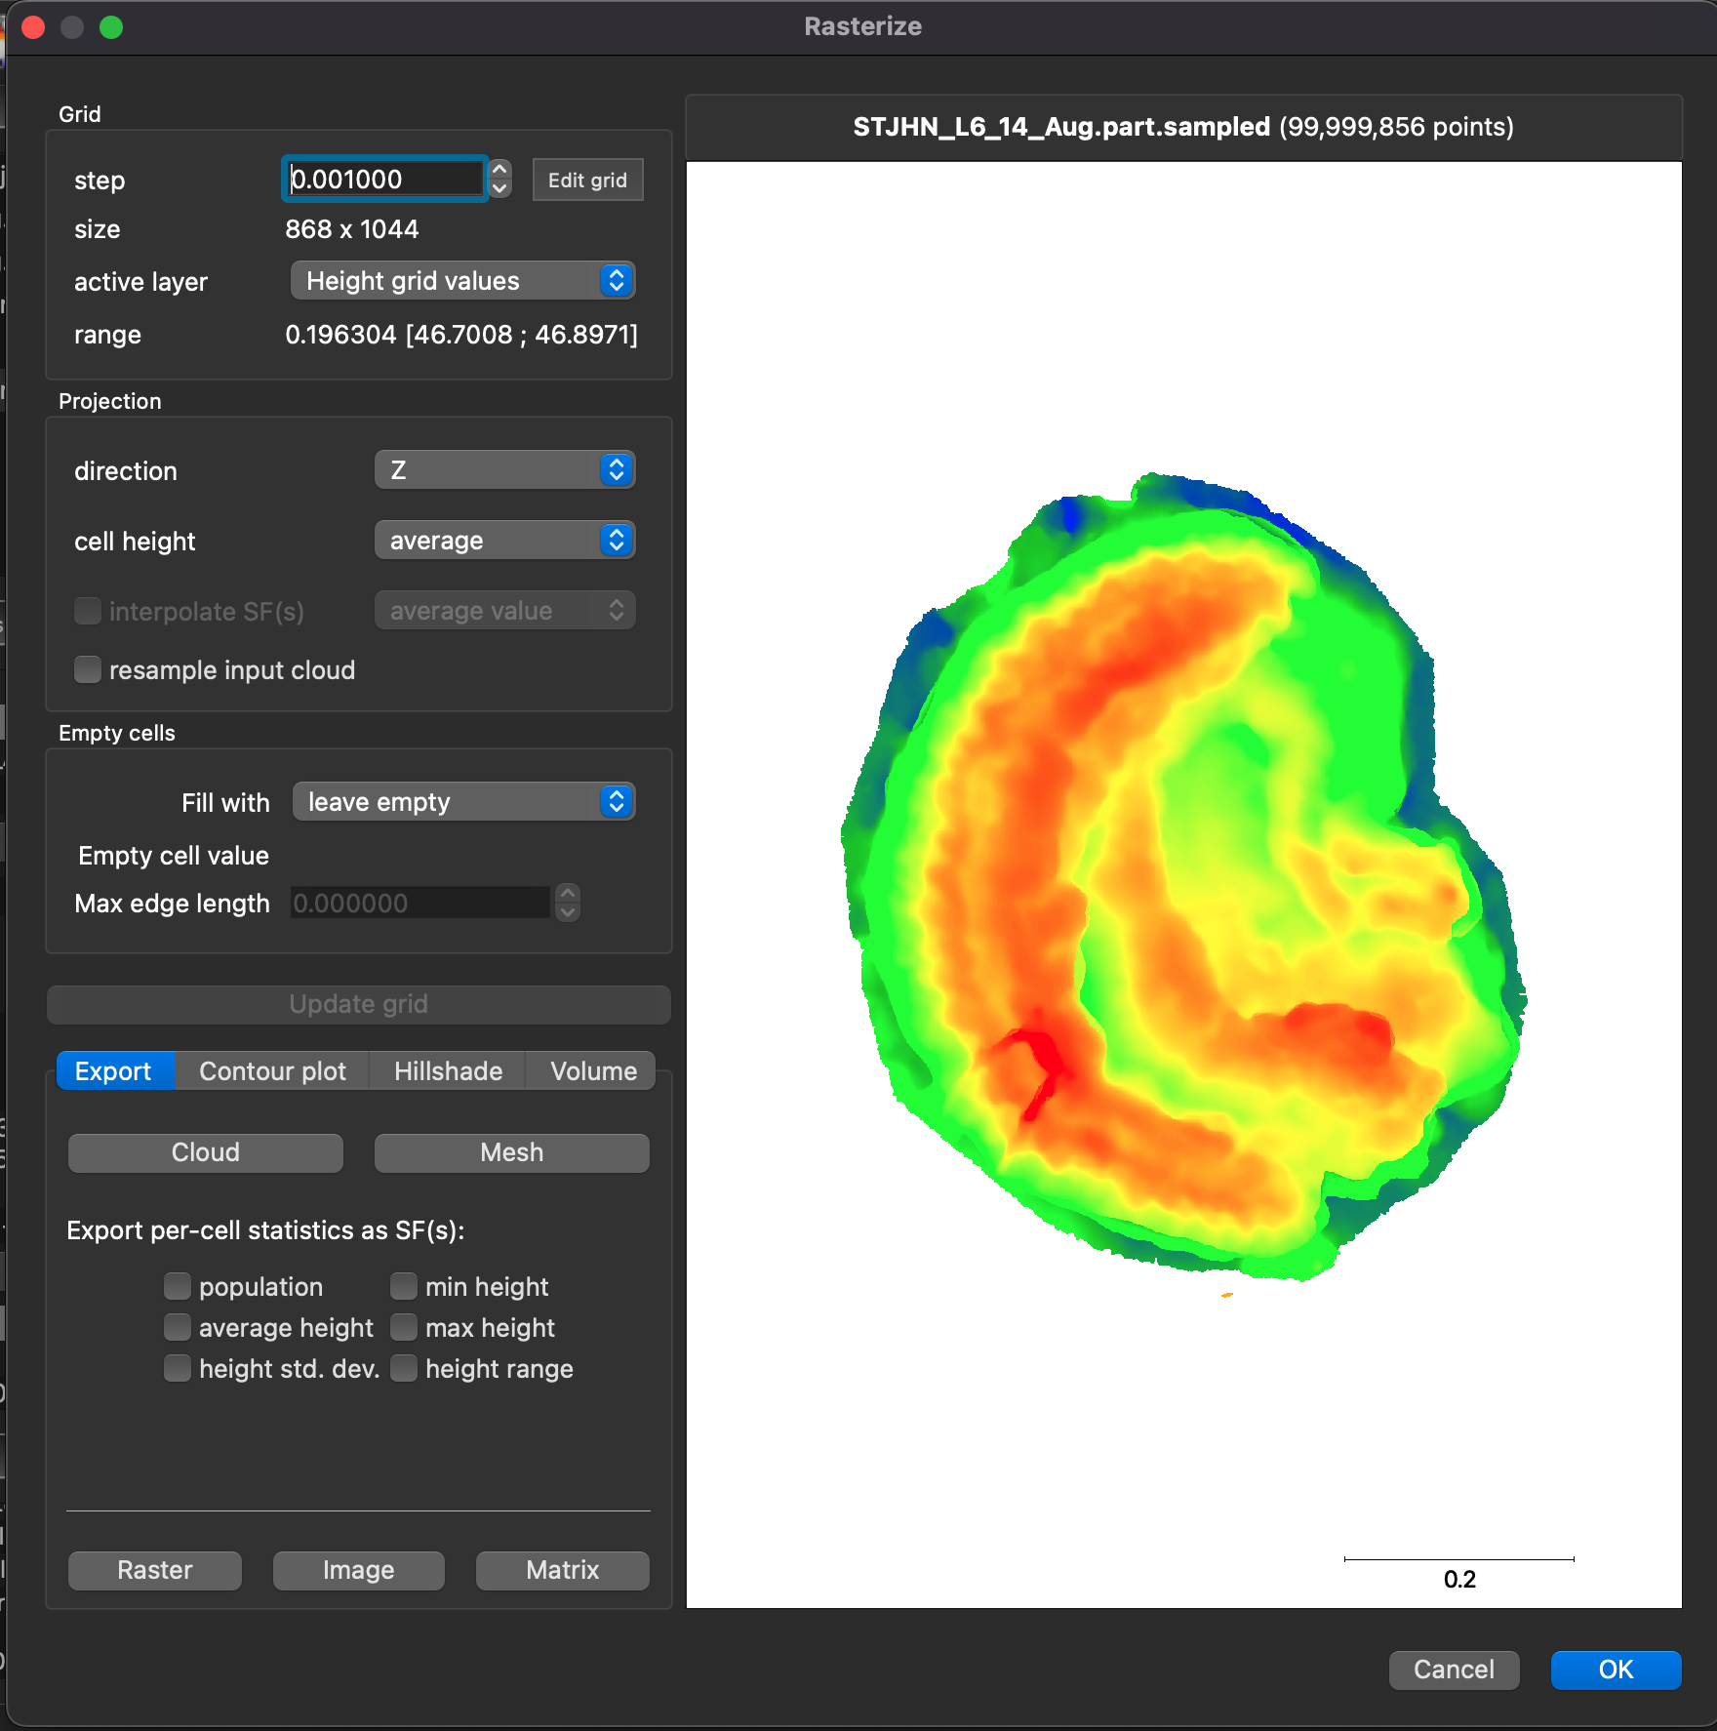 | Fig.S3C: When using the 'Rasterise' tool to transform the 3D point cloud into a 2.5D DEM, this window will appear. We recommend using a step value of 0.001, however this value might change depending on the size of the coral microatoll. To export a DEM in TIFF format, click on the 'Raster' button to complete this step.

S5 Source of uncertainty in final 3D model: Doming

In conventional photogrammetry, pre-calibration is performed to determine the camera's intrinsic and extrinsic parameters, using well-defined camera models that aid in data processing (James and Robson, 2014; Zhang et al., 2022). In contrast, SfM photogrammetry uses self-calibration, where the camera calibration occurs simultaneously during image processing. While this approach is less time- and labour-intensive than pre-calibration (Altuntas, 2021), it often results in a more pronounced central dome effect (shortened to 'doming') due to the nature of self-calibration (Griffiths and Burningham, 2019).

Doming can cause systematic broad-scale errors in the DEM and, hence, can degrade the accuracy in a DEM (Eltner et al., 2016; Magri and Toldo, 2017). Doming generally results from a combination of near-parallel imaging directions and inaccurate correction of radial lens distortion (Mali et al., 2018). To minimize the effects of doming, we must ensure an even distribution of GCPs. For example, in a radially concentric coral, there could be GCPs occupying positions in cardinal directions.

S6 Validation of Mapur Island 3D models

Prior to photographing the Mapur microatolls, a set of screws was put in each coral, at intervals marking the future location of the slab, with an additional reference screw that was kept in each coral to serve as a benchmark for future surveying. All of these screws appear in the photographs and were also surveyed precisely with a total station. A total of 4-5 screws per coral were used as GCP points to georeference the final model, leaving 3-4 other screws as check points to validate the georeferenced 3D model for each coral. To do this, we compared the coordinates derived from SfM for each check point with those obtained from the survey for the same point (Smith et al., 2015; Caroti et al., 2015; Iheaturu et al., 2022). From these check points, we calculated the root mean squared error (RMSE), which is a measure of how accurate our models are, based upon the difference between the surveyed and modelled positions of the check points (Table S3). This validation method has been used in several studies (e.g. Holata et al., 2018; Sanz-Ablanedo et al., 2018; Iheaturu et al., 2022). Low RMSE values give us confidence that our models are accurate, and that model-derived data are reliable. However, our limited number of check points (3-4) may be inadequate for thorough model validation. Future efforts should focus on increasing the number of check points to enhance the reliability of the validation process (Ren et al., 2020).

Table S3: Accuracy of the Mapur Island models based on model-predicted and survey-derived coordinate comparisons and corresponding RMSE values
Coral | No. of GCPs | No. of check points | Positional RMSE [x, y]  (m) | Vertical RMSE [z]  (m) | Total RMSE (m)
PMPR-B-F2 | 5 | 3 | 0.005 | 0.003 | 0.006
PMPR-B-F3 | 4 | 4 | 0.005 | 0.005 | 0.007
PMPR-B-F4 | 4 | 3 | 0.006 | 0.008 | 0.010
PMPR-B-F5 | 4 | 3 | 0.018 | 0.003 | 0.019

S7 Comparison between 3D modelling techniques

Since the development and refinement of 3D reconstruction techniques, we have incorporated them into our fieldwork within Singapore. This gives us the opportunity to conduct further analysis into each technique.

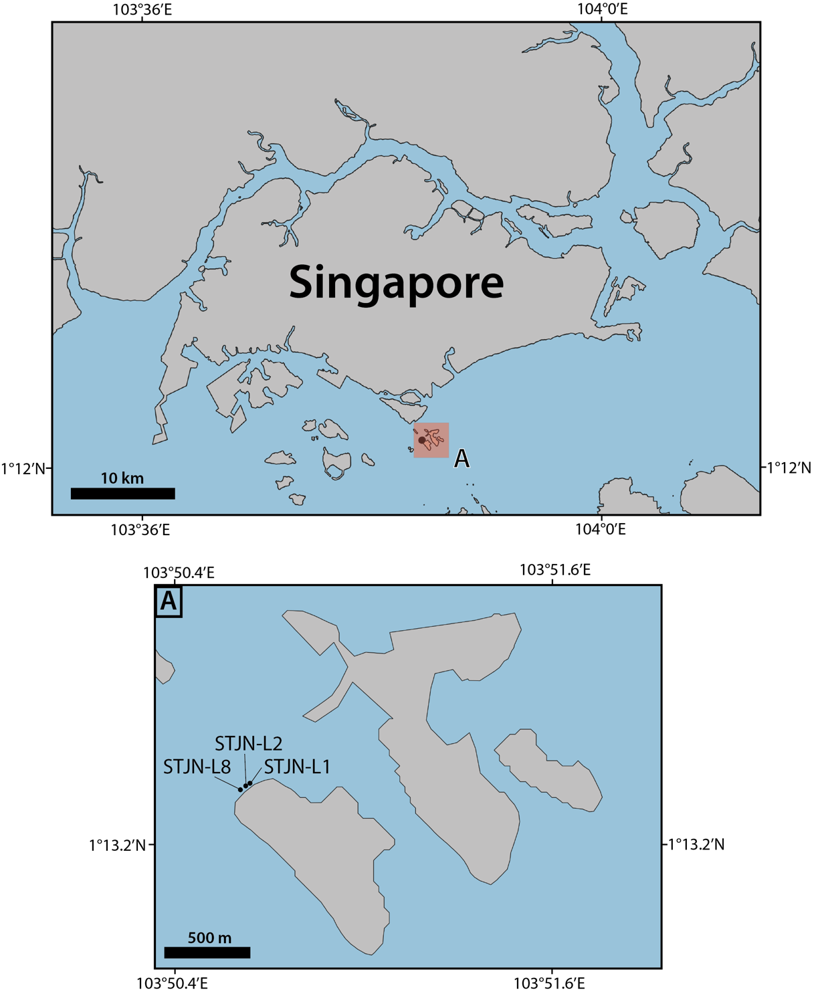
Fig.S4: St. John’s Island, in the Southern Islands of Singapore. (A) Location of the three living Porites sp. coral microatolls on St. John’s Island further analysed in this study.

St. John’s Island (Fig.S4) lies in the Southern Islands of Singapore. Located on the northern part of the island, the reef is approximately 250 m wide and 50 m long and contains several living Porites sp. coral microatolls. We reconstruct 3D models of three living microatolls (STJN-L1, -L2 and -L8) using both SfM photogrammetry and iPhone LiDAR scans. Data acquisition using both technique was done on the same day, facilitating direct comparison between the techniques.

To aid comparison, we adopt the same RMSE workflow as stated in Supporting Text S6. Using check points (unique points on the coral not assigned as GCPs), we calculated RMSE values between model-derived coordinates and TS-derived coordinates (Table S4).

Table S4: Accuracy comparison of 3D model reconstructions for three living corals from St. John’s Island, derived from both SfM photogrammetry and iPhone LiDAR scans. Accuracy is assessed by comparing model-predicted and survey-derived coordinates and calculating the corresponding RMSE values.
 |  |  | iPhone LiDAR scan |  |  | SfM photogrammetry
Coral | No. of GCPs | No. of check points | Positional RMSE [x, y]  (m) | Vertical RMSE [z]  (m) | Total RMSE (m) | Positional RMSE [x, y]  (m) | Vertical RMSE [z]  (m) | Total RMSE (m)
STJN-L1 | 4 | 2 | 0.003 | 0.012 | 0.012 | 0.007 | 0.013 | 0.015
STJN-L2 | 4 | 2 | 0.010 | 0.001 | 0.010 | 0.020 | 0.001 | 0.021
STJN-L8 | 4 | 3 | 0.033 | 0.009 | 0.034 | 0.011 | 0.009 | 0.014

Low RMSE values using either method give us confidence that both techniques used to create 3D models are accurate and can be used in further analyses.

Additionally, in the case of PARA-F1 (Section 3.3), due to a lack of surveying equipment, we relied on coordinates derived from the iPhone LiDAR scan to georeference the final model. Here we investigate the accuracy of iPhone-derived coordinates, using the three living microatolls from St. John’s Island. Since direct comparison between iPhone-derived coordinates and TS coordinates is not possible due to differing local reference frames, we compare distances between the same check points used in Table S4 computed from the direct iPhone LiDAR scan and using TS coordinates (Table S5). Since STJN-L8 had three checkpoints, three values were computed: check point 1-2, check point 2-3, check point 1-3.

Table S5: Assessing accuracy of direct coordinates obtained from iPhone LiDAR scans. Accuracy is validated by comparing calculated distances between checkpoints using both iPhone-derived coordinates and TS-derived coordinates.
Coral | No. of check points | Difference between true TS horizontal distance and iPhone-derived distance (m) | Difference between true TS vertical distance and iPhone-derived distance (m)
STJN-L1 | 2 | 0.004 | 0.003
STJN-L2 | 2 | 0.002 | 0.002
STJN-L8 | 3 | 0.006, 0.017, 0.025 | 0.003, 0.003, 0.006

The differences in distance are relatively low, indicating high accuracy, providing confidence iPhone-derived coordinates can be used for scaling. However, we document one mismatch as high as 2.5 cm. While low, this highlights the importance of georeferencing with TS coordinates whenever feasible.

S8 Comparison between 3D-model slice and physical slab

For the Mapur Island case study, we compared the 3D-model-derived radial slice and the radial profile of the physical slab (Fig.S5). To facilitate this comparison, we needed to place both the slice and physical slab profile in the same elevation frame. Since the 3D models of the Mapur fossil corals were georeferenced using GCPs surveyed with a total station, the elevations of the 3D model slices were in the local coordinate system. In contrast, the slab X-ray mosaic was processed in a vector graphics application such as Adobe Illustrator. Although it is correctly scaled, elevations from the slab profile are not in the local coordinate system. Work is needed to put the slab surface elevations back into the local coordinate system to enable direct comparison with the co-located slices.

To put the slab in the same vertical reference frame as the slice through the 3D model, we first identify the line of horizontality (LOH, described in Supporting Text S1) in the processed slab file. Since the screws in the slab are surveyed in the local coordinate system, and we know the vertical distance between the screws and the LOH, we can calculate the LOH elevation, and hence the elevations of all points on the slab profile, accurately within this reference frame. Elevations of the slab profile can thus be put back in the local coordinate system, by calculating the uniform vertical shift needed. With the slab profile in the same elevation frame as the co-located slices, we overlay the slab profile on the model-derived slice and then compare the two independent representations of the coral profile.

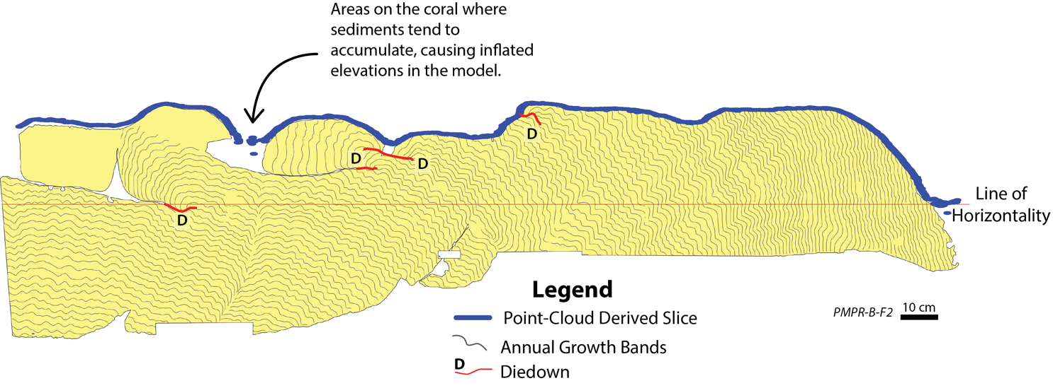
Fig.S5: An overlay of a point-cloud-derived slice on the corresponding annotated slab (Majewski, 2017) of Porites sp. coral PMPR-B-F2, a fossil microatoll from Mapur Island, shows notable similarities for most of the profile. The slice is extracted along the same radius from which the physical slab was taken. Neither the slab nor the slice has any vertical exaggeration.

S9 PARA-F1 slab analysis

PARA-F1 is located in Paraoir, a coastal barangay (village) in the municipality of Balaoan, La Union province, on the northwestern coast of Luzon, Philippines. Due to its proximity to the Manila Trench, tectonics is an additional driver of RSL change in Paraoir.

Sarkawi (2024) analyzed and interpreted two separate physical slices of PARA-F1, several centimetres apart. For our study, the intent is not strictly to produce the most complete interpretation of the physical slab of the coral; rather, we aim to illustrate information that is sometimes not recorded or preserved in a slab, but which could be obtained from a 3D model of the microatoll surface. For this reason, it is sufficient to compare the results from the 3D model to only one of the physical slices of PARA-F1. For a thorough interpretation of the PARA-F1 slab, we refer the reader to Sarkawi (2024).

Slab analysis (Fig.S6) revealed four distinct outer rings (R1-R4), characterized by well-defined crests and troughs, as well as a low centre. Between the centre and the outer rings, only two additional rings were identified (R5/R6 and R7/R8), even though four rings had been inferred over that interval from the surface morphology. The identification of the additional rings could be accomplished only by projecting the ring boundaries from the surface morphology into the slab, with additional insights drawn from field sketches and photos. Further investigation also revealed two additional diedowns (Fig.S6: one of them is located within the low centre and has been covered by younger coral growth, whereas the second diedown is located in the interior of R2 and has been partially concealed by overgrowth, in addition to in-sequence growth.

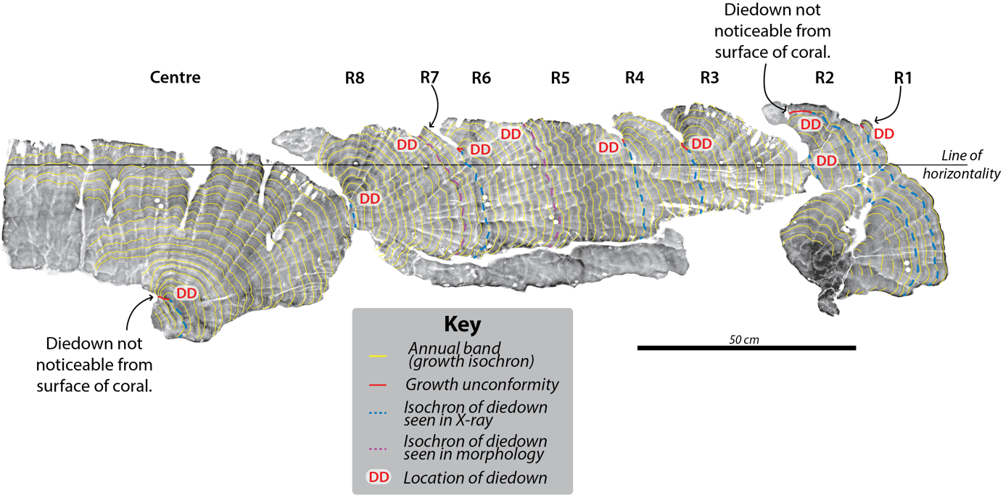
Fig.S6: Annotated slab of Porites sp. coral PARA-F1, a fossil microatoll from the Paraoir site, modified from Sarkawi (2024).

References for Supporting Information
Agisoft LLC. (2021). Agisoft Metashape User Manual, Professional Edition, Version 1.7. Available at: https://www.agisoft.com/pdf/metashape-pro_1_7_en.pdf (Accessed: 15 October 2024).
Altuntas, C. (2021). Camera self-calibration by using SfM based dense matching for close-range images, Eurasian Journal of Science Engineering and Technology, 2(2), pp.69-82. Available from: https://dergipark.org.tr/en/pub/ejset/issue/66075/982027.
Caroti, G., Zaragoza, I.M.-E. and Piemonte, A. (2015). Accuracy assessment in structure from motion 3D reconstruction from UAV-born images: the influence of the data processing methods, The International Archives of the Photogrammetry, Remote Sensing and Spatial Information Sciences, XL-1/W4, pp.103-109. https://doi.org/10.5194/isprsarchives-xl-1-w4-103-2015.
Catalucci, S., Marsili, R., Moretti, M. and Rossi, G. (2018). Comparison between point cloud processing techniques, Measurement, 127, pp. 221–226. https://doi.org/10.1016/j.measurement.2018.05.111.
Eltner, A., Kaiser, A., Castillo, C., Rock, G., Neurgirg, F. and Abellán, A. (2016). Image-based surface reconstruction in geomorphometry – merits, limits and developments, Earth Surface Dynamics, 4(2), pp. 359–389. https://doi.org/10.5194/esurf-4-359-2016.
Flora, C.J. and Ely, P.S. (2003). Surface growth rings of Porites lutea microatolls accurately track their annual growth, Northwest science, 77(3), pp.237-245. https://hdl.handle.net/2376/798.
Goreau, T.F., Goreau, N.I. and Goreau, T.J. (1979). Corals and coral reefs, Scientific American, 241(2), pp.124-137. http://www.jstor.org/stable/24965267.
Griffiths, D. and Burningham, H. (2019). Comparison of pre- and self-calibrated camera calibration models for UAS-derived nadir imagery for a SfM application, Progress in Physical Geography, 43(2), pp.215-235. https://doi.org/10.1177/0309133318788964.
Holata, L., Plzák, J., Světlik, R. and Fonte, J. (2018). Integration of low-resolution ALS and ground-based SFM photogrammetry data: a cost-effective approach providing an ‘enhanced 3D model’ of the Hound Tor archaeological landscapes (Dartmoor, South-West England), Remote Sensing, 10(9), p. 1357. https://doi.org/10.3390/rs10091357.
Iglhaut, J., Cabo, C., Puliti, S., Piermattei, L., O’Connor, J. and Rosette, J. (2019). Structure from motion photogrammetry in forestry: a review, Current Forestry Reports, 5(3), pp. 155–168. https://doi.org/10.1007/s40725-019-00094-3.
Iheaturu, C.J., Ayodele, E.G. and Okolie, C.J. (2020). An assessment of the accuracy of structure-from-motion (SfM) photogrammetry for 3D terrain mapping, Geomatics, Landmanagement and Landscape, 2, pp. 65–82. https://doi.org/10.15576/gll/2020.2.65.
James, M.R. and Robson, S.R. (2014). Mitigating systematic error in topographic models derived from UAV and ground-based image networks, Earth Surface Processes and Landforms, 39, pp.1413-1420. https://doi.org/10.1002/esp.3609.
Järvenpää, A. (2021). Metrological characterization of a consumer grade flash LiDAR device. M.Sc. thesis. Aalto University. Available from: https://urn.fi/URN:NBN:fi:aalto-2021121910925.
Kasprzak, M., Jancewicz, K. and Michniewicz, A. (2017). UAV and SfM in detailed geomorphological mapping of granite tors: an example of Starościńskie Skały (Sudetes, SW Poland), Pure and Applied Geophysics, 175(9), pp. 3193–3207. https://doi.org/10.1007/s00024-017-1730-8.
Lange, I.D. and Perry, C.T. (2020). A quick, easy and non‐invasive method to quantify coral growth rates using photogrammetry and 3D model comparisons, Methods in Ecology and Evolution, 11(6), pp. 714–726. https://doi.org/10.1111/2041-210x.13388.
Lebrat, L., Santa Cruz, R., Fookes, C. and Salvado, O. (2021) MongeNet: Efficient Sampler for Geometric Deep Learning, arXiv. https://doi.org/10.48550/arXiv.2104.14554
Leduc, P., Peirce, S. and Ashmore, P. (2019). Short communication: challenges and applications of structure-from-motion photogrammetry in a physical model of a braided river, Earth Surface Dynamics, 7(1), pp. 97–106. https://doi.org/10.5194/esurf-7-97-2019.
Lozano-Cortés, D.F. and Zapata, F.A. (2014). Invertebrate colonization on artificial substrates in a coral reef at Gorgona Island, Colombian Pacific Ocean, Rev. Biol. Trop. 62(1), pp.161-168. https://doi.org/10.15517/rbt.v62i0.16273.
Luetzenburg, G., Kroon, A. and Bjørk, A.A. (2021). Evaluation of the Apple iPhone 12 Pro LIDAR for an application in geosciences, Scientific Reports, 11(1). https://doi.org/10.1038/s41598-021-01763-9.
Magri, L. and Toldo, R. (2017). Bending the doming effect in structure from motion reconstructions through bundle adjustment, The International Archives of the Photogrammetry, Remote Sensing and Spatial Information Sciences, XLII-2/W6, pp. 235–241. https://doi.org/10.5194/isprs-archives-xlii-2-w6-235-2017.
Mali, V.K. and Kuiry, S.N. (2018). Assessing the accuracy of high-resolution topographic data generated using freely available packages based on SfM-MVS approach, Measurement, 124, pp. 338–350. https://doi.org/10.1016/j.measurement.2018.04.043.
Mali, V.K., Venu, P., Nagaraj, M.K. and Kuiry, S.N. (2021). Demonstration of structure-from-motion (SfM) and multi-view stereo (MVS) close range photogrammetry technique for scour hole analysis, Sādhanā, 46(4). https://doi.org/10.1007/s12046-021-01758-2.
Majewski, J.M. (2017). Coral microatoll based sea level records from the Sunda Shelf. Ph.D. thesis, Nanyang Technological University. http:doi.org/10.32657/10356/73241.
Meltzner, A.J., Woodroffe, C.D. (2015). Coral microatolls. In: Shennan, I., Long, A.J., Horton, B.P. eds. Handbook of Sea‐Level Research. UK: John Wiley & Sons, pp. 125–145.
Mosbrucker, A.R., Major, J.J., Spicer, K.R., Pitlick, J. (2017). Camera system considerations for geomorphic applications of SfM photogrammetry, Earth Surface Processes and Landforms, 42(6), pp. 969–986. https://doi.org/10.1002/esp.4066.
Natawidjaja, D.H., Sieh, K., Chlieh, M., Galetzka, J., Suwargadi, B.W., Cheng, H., Edwards, R.L., Avouac, J.-P. and Ward, S.N. (2006). Source parameters of the great Sumatran megathrust earthquakes of 1797 and 1833 inferred from coral microatolls, Journal of Geophysical Research, 111(B6). https://doi.org/10.1029/2005jb004025.
Park, H., Lee, D. (2019). Comparison between point cloud and mesh models using images from an unmanned aerial vehicle, Measurement, 138, pp.461–466. https://doi.org/10.1016/j.measurement.2019.02.023.
Ren, H., Zhao, Y., Xiao, W., Wang, X. and Sui, T. (2020). An improved ground control point configuration for digital surface model construction in a coal waste dump using an unmanned aerial vehicle system, Remote Sensing, 12(10), p. 1623. https://doi.org/10.3390/rs12101623.
Sanz-Ablanedo, E., Chandler, J.H., Rodríguez-Pérez, J.R. and Ordóñez, C. (2018). Accuracy of unmanned aerial vehicle (UAV) and SFM photogrammetry survey as a function of the number and location of ground control points used, Remote Sensing, 10(10), p. 1606. https://doi.org/10.3390/rs10101606.
Sarkawi, G.M. (2024). Insights from coral microatolls into sea-level variability and subduction zone behavior. Ph.D. thesis, Nanyang Technological University. https://doi.org/10.32657/10356/174449.
Smith, M.W., Carrivick, J.L. and Quincey, D.J. (2015). Structure from motion photogrammetry in physical geography, Progress in Physical Geography, 40–2, pp. 247–275. https://doi.org/10.1177/0309133315615805.
Tavani, S., Billi, A., Corradetti, A., Mercuri, M., Bosman, A., Cuffaro, M., Seers, T. and Carmineti, E. (2022). Smartphone assisted fieldwork: towards the digital transition of geoscience fieldwork using LiDAR-equipped iPhones, Earth-Science Reviews, 227, p. 103969. https://doi.org/10.1016/j.earscirev.2022.103969.
Turk, G. (1990) Generating random points in triangles. In: Glassner, A.S. eds. Graphic Gems. US: Academic Press Professional, pp. 24-28.
Zachariasen., Sieh, K., Taylor, F.W. and Hantoro, W.S. (2000). Modern vertical deformation above the Sumatran Subduction Zone: paleogeodetic insights from coral microatolls, Bulletin of the Seismological Society of America, 90(4), pp. 897–913. https://doi.org/10.1785/0119980016.
Zhang, Y., Yang, J., Li, G., Zhao, T., Song, X., Zhang, S., Li, A., Bian, H., Li, J. and Zhang, M. (2022). Camera calibration for long-distance photogrammetry using unmanned aerial vehicles, Journal of Sensors, 2022. https://doi.org/10.1155/2022/8573315.

