Errata

Doctoral candidate: Marcin Jakub Domagalski

Thesis title: Structure determination and functional analysis of isochorismate synthase
DhbC from Bacillus anthracis using the state of the art SG data management system

Page/line | Original text | Corrected text
i / 9 | Janusz M. Bujnicki, Ph.D., D.Habil. | Janusz M. Bujnicki, Ph.D., D.Habil., Prof.
5 / 2 | odpornych na antybiotyki | opornych na antybiotyki
6 / 13 | krystalografii rentgenowskiej pojedynczych kryształów | krystalografii rentgenowskiej monokryształów
18 / 11 | mediated by hydrogen and electrostatic bond interactions | mediated by hydrogen bonds and electrostatic interactions
18 / 31 | reciprocal interference between X-rays | constructive interference between X-rays
19 / 12 | exp(-2πihx+ky+lz) | exp[-2πi(hx+ky+lz)]
19 / 13 | where hkl are measured intensities, V is the volume of the unit cell, and α _{hkl} is the phase corresponding to the structure-factor amplitude |F_{hkl}| | where V is the volume of the unit cell,  and α_{hkl} is the phase corresponding to the structure-factor amplitude |F_{hkl}|
20 / 12 | The contribution of heavy atoms to each structure factor can be calculated using the Patterson function or direct methods. | The isomorphous difference, asymptotically equal to the difference between amplitude of a reflection for the derivative crystal and amplitude of a reflection for the native crystal, can be used as an estimate of the heavy-atom structure-factor amplitude to determine the heavy-atom positions using Patterson or direct methods.
21 / 11 | An initial density map can be obtained for a structure using the Patterson function, which discards the phases and using squared amplitudes. | -
22 / 24 | In January 1998, a workshop on Structural Genomics was held at Argonne National Laboratory in USA and initial pilot projects started in Germany, Canada, and USA. | In January 1998, a workshop on Structural Genomics was held at Argonne National Laboratory in USA and initial pilot projects started in Germany  (Protein Struktur Fabrik), Canada (Structural Genomics Consortium),  and USA.
30 / 1 | over 108,000 structures | over 108,000 structures  (as on 15 April 2015)
44 / 14 | 8000 rpm | 8000 rpm (~6000 x g)
45 / 17 | 35,000 rpm | 35,000 rpm (~142,500 x g)
47 / 19 | 14,000 rpm | 14,000 rpm (~19,000 x g)
Modified Figures:

Figure 6 Purification check of DhbC by SDS-PAGE. Lane 1 – protein standards, lane 2 –cell lysate,
lane 3 – Ni-NTA flow-through, lane 4 – Ni-NTA washing fractions, lane 5 – Ni-NTA eluted DhbC,
lane 6 – DhbC after His-tag cleavage and second Ni-NTA, lane 7 – concentrated DhbC fractions
from FPLC

Figure 25 Results of the enzyme activity assay, which monitors formation of isochorismate by measuring increase of absorbance at 278nm (Δεisochorismate-chorismate = 10211 M⁻¹ cm⁻¹). The absorbance curves were made by averaging three repeats of the experiment.

Additional Figures:
1.2.3. 1
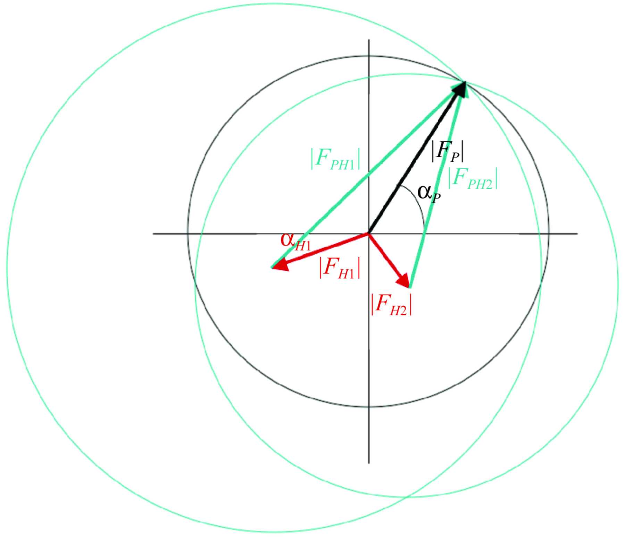
Figure 27. Harker diagram for MIR with two heavy-atom derivatives. . Image reprinted from an original article (Taylor 2003).

1.2.3.2
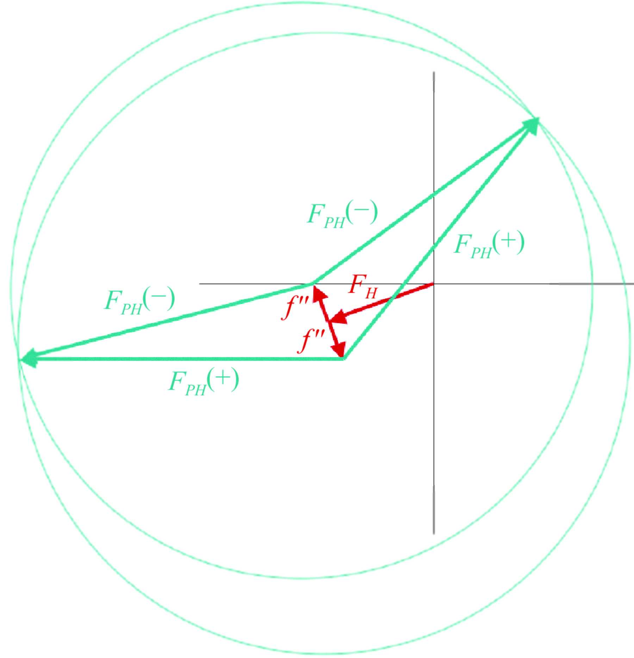
Figure 28. Harker construction for SAD. ΔF± is used to find the substructure of anomalous scatterers, followed by phasing and phase improvement. Image reprinted from an original article (Taylor 2003).

