Supplementary material to

Multiproxy paleoceanographic study from the western Barents Sea reveals dramatic Younger Dryas onset followed by oscillatory warming trend
Magdalena Łącka¹*, Danuta Michalska², Joanna Pawłowska¹, Natalia Szymańska¹, Witold Szczuciński², Matthias Forwick³ and Marek Zajączkowski¹

¹Institute of Oceanology, Polish Academy of Sciences, Powstańców Warszawy 55, 81-712 Sopot, Poland
²Institute of Geology, Adam Mickiewicz University in Poznań, Bogumiła Krygowskiego 12, 61-680 Poznań, Poland
³Department of Geosciences, UiT The Arctic University of Norway in Tromsø, N-9037 Tromsø, Norway

*corresponding author mlacka@iopan.gda.pl

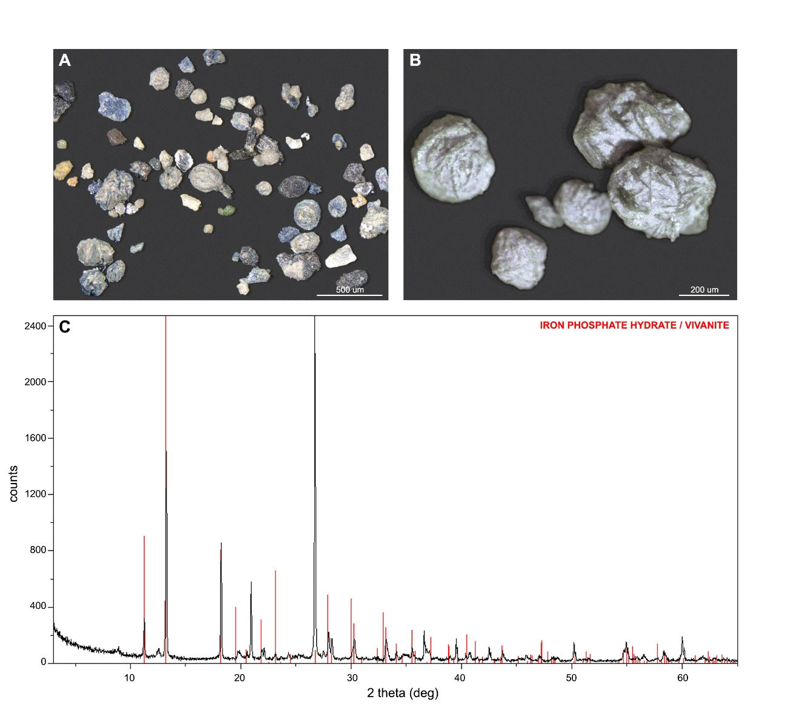Supplementary Figure S1. Vivianite nodules; A, B- macroscopic view of sediment and microconcretions; C- X-Ray diffraction (XRD) spectra of vivianite microconcretions.
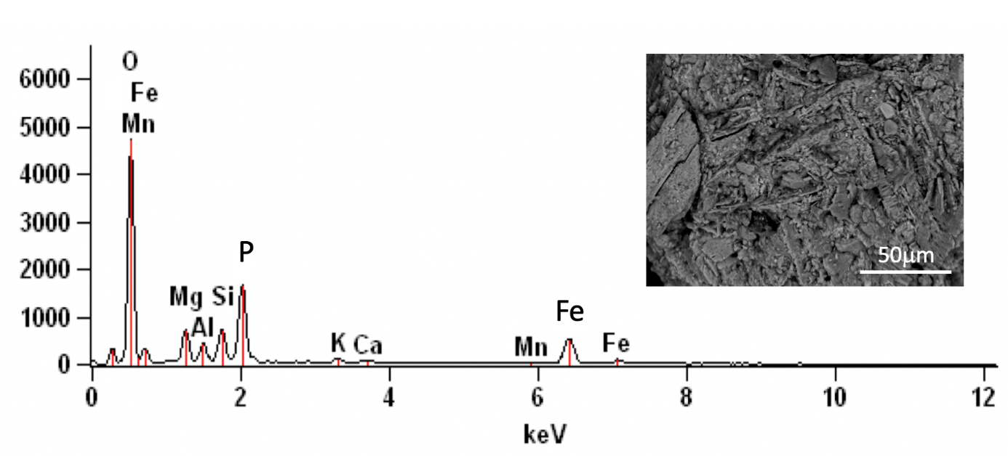
Supplementary Figure S2. EDS spectra of outer surfaces of vivianite microconcretions; vivianite with impurities of silicate indicated by small peaks of Na, Mg, Al, Si, Ca and Mn.
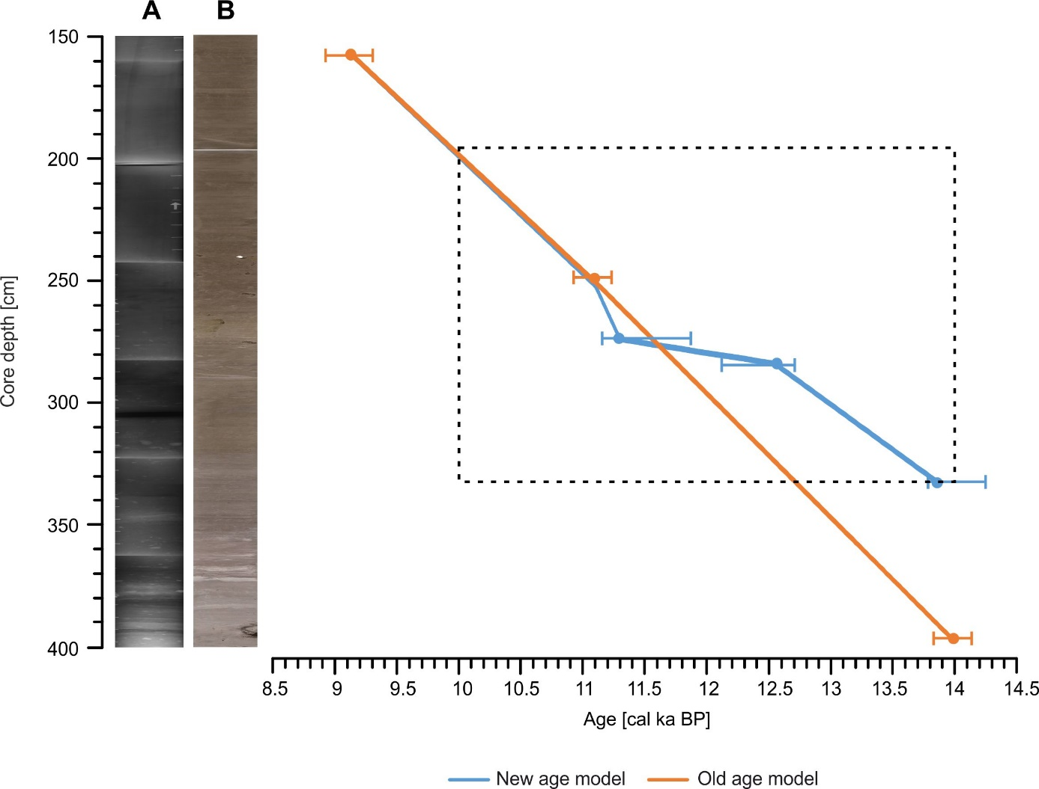Supplementary Figure S3. Comparison between age model of core JM09-020-GC published in Łącka et al. 2015 and the age model used in this study with 2-sigma age probability distribution indicated. On the left are (A) X-radiographs and (B) digital photographs of the core. The dashed lines mark the studied section.

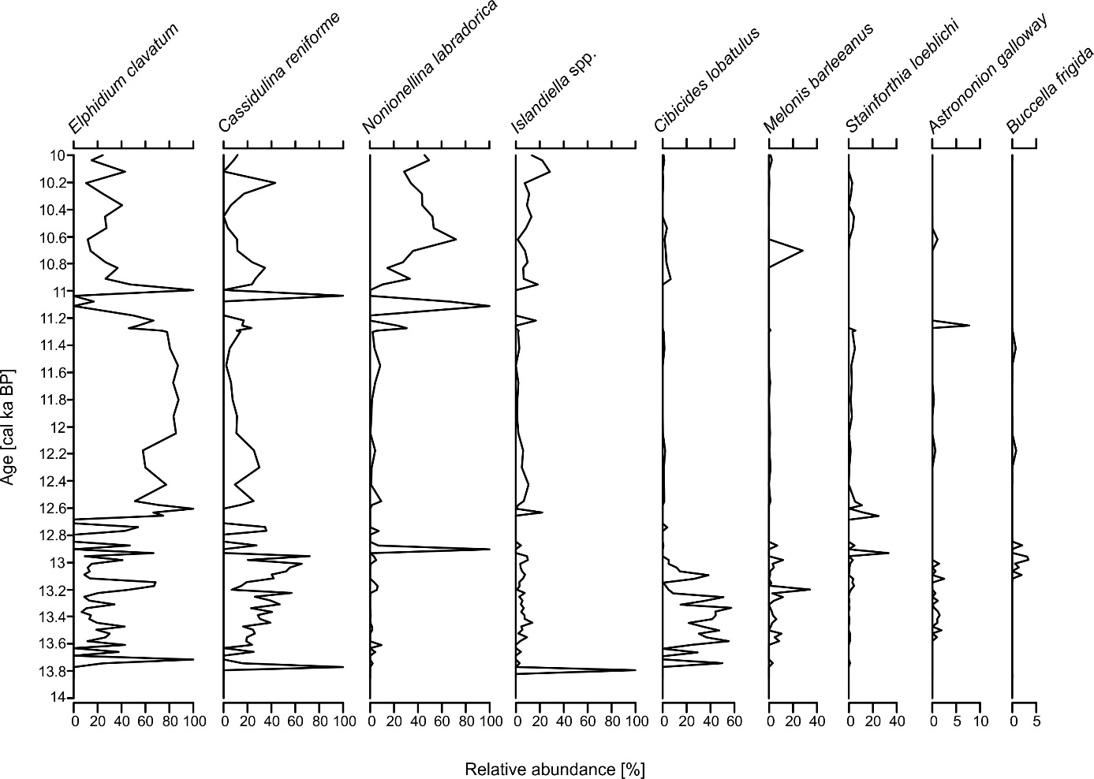
Supplementary Figure S4. Relative abundances of the 9 most common benthic foraminifera species in core JM09-020-GC.

