This is the revised version of the article:
Mądra-Bielewicz A., Matuszewski, S. (2026), Parent-offspring competition for food constrains parental care in communal carrion beetles,
The final version was published in Animal Behaviour https://doi.org/10.1016/j.anbehav.2026.123471

Parent-offspring competition for food constrains parental care in communal carrion beetles

Anna Mądra-Bielewicz, Szymon Matuszewski*

Laboratory of Criminalistics, Adam Mickiewicz University, Al. Niepodległości 53, 61-714 Poznań, Poland
Center for Advanced Technologies, Adam Mickiewicz University, Uniwersytetu Poznańskiego 10, 61-614 Poznań, Poland

*Corresponding author: szymmat@amu.edu.pl; Laboratory of Criminalistics, Adam Mickiewicz University, Uniwersytetu Poznańskiego 10, 61-614 Poznań, Poland; tel. +48618294292

Abstract
Parents and offspring of many animals regularly share food resources, which may promote competition among kin for food and ultimately constrain the development of family life. We hypothesize that parent-juvenile competition for shared food is especially intense in communal systems, particularly those that exploit ephemeral resources (e.g. carrion), promoting early dispersal of adults from a shared resource and in this way constraining parental care. We tested this hypothesis in communal carrion beetles Necrodes littoralis (Staphylinidae), a species colonizing cadavers of large vertebrates that exhibit no post-hatching forms of parental care. By manipulating the number of adult beetles, the time they stay on food resources and the quality of that resources, we provide evidence that parent-juvenile competition for food on carrion has a constraining effect on parental care in communal carrion beetles. When we doubled the time spent by adult beetles on shared food, there was a clear negative effect on juvenile fitness, but doubling the number of the beetles had no significant effect. Therefore, parent-juvenile competition for shared food resources limits primarily the time adult communal beetles stay on carrion. By promoting earlier dispersal of adult beetles from a nesting site, this form of competition reduces the time window for potential adult-juvenile interactions, which makes post-hatching care virtually impossible to develop in these beetles. These findings highlight the importance of competitive adult-juvenile interactions in the large communal groups that use high-quality ephemeral resources.

Keywords: Intraspecific competition; Food sharing; Parental care; Ephemeral resources; Parent-offspring conflict; Carrion insects; Necrodes
Introduction
Parents and offspring may compete for food, mating partners or territory (Kramer & Meunier, 2019). This form of kin interaction is widespread across animals and is considered an important constraint for family living. There is ample evidence that parent-offspring competition promotes breakdown of family groups by instigating dispersal of juveniles, for instance in carrion crow Corvus corone corone (Baglione, Canestrari, Marcos, & Ekman, 2006), little owl Athene noctua (Fattebert, Perrig, Naef-Daenzer, & Grüebler, 2019), western slaty-antshrike Thamnophilus atrinucha (Tarwater & Brawn, 2010), common lizard Lacerta vivipara (Cote, Clobert, & Fitze, 2007), African striped mouse Rhabdomys pumilio (Schoepf & Schradin, 2012) and meerkat Suricata suricatta (T. H. Clutton-Brock et al., 2001). In altricial species parents and their offspring usually start to compete at the end of the family life, thus their competition can constrain emergence of multi-generational groups (i.e. ‘extended families’) but at the same time has no or little effect on nuclear families (Kramer & Meunier, 2019). Conversely, in precocial species parents and offspring may compete from the very beginning of family life and the competition may affect the type and duration of their relationship. In a burying beetle Nicrophorus vespilloides, a species with facultative biparental care, where parents and offspring share small mammal carcasses as food, kin competition for these resources may promote early dispersal of fathers from the nest (Boncoraglio & Kilner, 2012; Keppner, Ayasse, & Steiger, 2020). Under food limitation conditions parent-offspring competition can even cancel the benefits of post-hatching parental care, as has been evidenced for European earwig Forficula auricularia, a species with maternal care, but in which nymphs can forage and survive on their own in the absence of the mother (Meunier, 2024; Meunier & Kölliker, 2012). Following this line of reasoning, competition between family members for food resources may limit the evolution of more elaborate forms of parental care by promoting early parental dispersal from a nesting site and thus shortening the time window for potential parent-offspring interactions. This mechanism may completely prevent post-hatching care, and reduce pre-hatching care, especially in species that frequently experience food shortages, such as those relying on ephemeral food resources.
Ephemeral resources, e.g. dung, carrion, dead wood or fallen fruits, due to their non-renewable and consumable nature generally promote competition (Beaver, 1977; Butterworth, Benbow, & Barton, 2023; Shorrocks, 1991). Some of them are of high nutritional quality, which causes intense competition among their consumers and, consequently, rapid resource depletion, as exemplified by vertebrate carrion (Barton et al., 2024; Hanski, 1987). Ephemeral resources can be colonized by fewer individuals, especially those of small size (e.g. invertebrate carrion), low nutritional quality (e.g. dead wood) or significant unpredictability in their duration (e.g. temporary water pools), as exemplified by the brood partitioning behavior of tropical poison frogs (Dendrobatidae), which spread tadpoles across several water pools due to their unpredictable duration (Erich, Ringler, Hödl, & Ringler, 2015; Ringler, Rojas, Stynoski, & Schulte, 2023). However, when the resources are large and of high nutritional value (e.g. large vertebrate carrion), they are usually colonized communally.
Carrion is an example of the ephemeral resource that hosts distinct consumer communities, mostly necrophagous insects, for which the highly competitive nature of this resource is extremely important. Interspecific, mostly exploitative, competition shapes these communities in terms of their diversity, abundance and duration, as well as the type and scope of group living of individual species (Costa, 2006; MacInnis & Higley, 2020; Matuszewski & Mądra-Bielewicz, 2022; Potticary et al., 2024; Wong, Meunier, & Kölliker, 2013). For example, competition with carrion flies and congeners contributed significantly to the evolution of elaborate parental care in burying beetles (Potticary et al., 2024; Pukowski, 1933; Scott, 1998). Competition with carrion flies also promoted the evolution of simple forms of pre-hatching parental care in communal carrion beetles, especially Ptomascopus, Necrodes or Diamesus species (Staphylinidae: Silphinae) (Matuszewski & Mądra-Bielewicz, 2022; Peck, 1982; Růžička, Jakubec, Mahlerová, Šípková, & Nishikawa, 2023; Suzuki & Nagano, 2006). Intraspecific competition is also highly important for necrophagous insects. Conspecific intruders, similarly to congeners, can destroy broods of burying beetles (Staphylinidae: Nicrophorus) (Robertson, 1993; Trumbo, 1990). Burying beetle larvae (usually siblings) compete with each other for carrion resources and food provisioned by adult beetles (Schrader, Jarrett, & Kilner, 2015; Smiseth, Lennox, & Moore, 2007). In the case of large carrion, exploitative competition between conspecific larvae is common and can be intense, especially when food resources are depleted, as has been demonstrated for larvae of blow flies (Calliphoridae) or Necrodes beetles (Staphylinidae: Silphinae) (Hanski, 1987; Johnson & Wallman, 2014; Lis, Mądra‐Bielewicz, Wydra, & Matuszewski, 2024). Furthermore, because adult and larval beetles share the same carrion as food, a parent-juvenile competition for food is inevitable in these systems. In burying beetles feeding of adults was consistently found to decrease carcass mass, but this surprisingly had only minor negative or mixed positive and negative effects on offspring fitness (Gray, Richardson, Ratz, & Smiseth, 2018; Keppner et al., 2020; Keppner, Laubenthal, Prang, Conrad, & Steiger, 2023; Trumbo & Xhihani, 2015). These results indicate that food sharing and resultant kin competition do not necessarily limit family life, although they promote earlier dispersal of males from a nest and in this way constrain post-hatching biparental care (Boncoraglio & Kilner, 2012; Keppner et al., 2020). A more consistent negative effects of food sharing were found in Necrodes littoralis L. (Staphylinidae: Silphinae), a communal carrion beetle that colonizes large cadavers (Lis et al., 2024; Matuszewski & Mądra-Bielewicz, 2021).
In the case of communal carrion insects that colonize large carcasses, dozens or even hundreds of females may oviposit on or near the same carrion, leading to the formation of aggregations consisting of hundreds to thousands of larvae, a typical scenario for some blow flies or silphid beetles (Damien Charabidze et al., 2021; Gruszka et al., 2020; Rivers, Thompson, & Brogan, 2011). Such communality may limit parental care, primarily because individual parental actions are likely to affect any larvae in the aggregation and not necessarily the offspring of a given parent. In addition, a large number of adult insects can make the parent-juvenile competition for shared food resources intense and likely to cause detrimental effects for the fitness of juveniles. Despite these constraints, some forms of parental care occur in communal carrion beetles. Adult Necrodes and Ptomascopus beetles were found to eradicate fly larvae from carrion, with recent results indicating that this behavior of the beetles is adaptive in terms of securing carrion as a food source for the juveniles (Matuszewski & Mądra-Bielewicz, 2022; Suzuki & Nagano, 2006). Killing maggots not only provides immediate nutritional benefits to the beetles, but also important deferred benefits to their offspring, which can play an important role in maintaining this behavior. This is an example of an evolutionary pathway that appears to promote parental care in communal systems on ephemeral resources, especially carrion. A behavior that is initially performed for the individual benefit of an adult insect evolves into the behavior that is maintained primarily for the benefit of its offspring. Furthermore, adult N. littoralis were found to form a ‘feeding matrix’. They spread their exudates (anal and likely oral as well) over carrion surface (or meat surface) and in this way creates a specific microenvironment by preserving and predigesting the food substrate (Matuszewski & Mądra-Bielewicz, 2021). In the matrix the heat is produced and it likely preserves carrion and facilitates subsequent feeding of the larvae, which may have a positive effect on their fitness (Hoback, Bishop, Kroemer, Scalzitti, & Shaffer, 2004; Matuszewski & Mądra-Bielewicz, 2021). However, such positive effect was found only under low self-feeding pressure from adult beetles, i.e. in conditions of relaxed parent-offspring competition for food (Matuszewski & Mądra-Bielewicz, 2021) or at low larval densities, i.e. in conditions of relaxed larval competition for food (Lis et al., 2024). These findings suggest that food sharing by adults and juveniles can be particularly important for communal carrion beetles, shaping the extent of family life that may develop in these systems.
In this study, we tested the hypothesis that parent-offspring competition for food limits parental care in a communal carrion beetle Necrodes littoralis. This is a Palearctic species that colonizes large cadavers (including humans), where under optimal conditions massive aggregations of its larvae can occur (Bonacci et al., 2022; D. Charabidze, Vincent, Pasquerault, & Hedouin, 2016; Dekeirsschieter, Frederickx, Verheggen, Boxho, & Haubruge, 2013; Gruszka & Matuszewski, 2022). The species exhibits pre-hatching parental care in the form of the clearing carrion of fly larvae and the formation of a feeding matrix, with its inherent thermogenesis (Matuszewski & Mądra-Bielewicz, 2021, 2022). No form of post-hatching care is known in this species (Damien Charabidze et al., 2021; Matuszewski & Mądra-Bielewicz, 2021). Previous studies suggested the importance of parent-juvenile competition for shared food resources in this species (Lis et al., 2024; Matuszewski & Mądra-Bielewicz, 2021). Therefore, we hypothesized that this form of kin competition explains the lack of any form of post-hatching parental care in these beetles. We predicted that – if this hypothesis holds – experimentally increased density or time spent by adult beetles on the resource will have clear negative effects on the components of juvenile fitness. To test this prediction, we created conditions of intense and relaxed parent-juvenile competition by directly manipulating the number of adult beetles, the time they spent on the shared food resource and the quality of that resource. In this context, we expected that a high density of adult beetles or their long-lasting residency on the resource (i.e. conditions of intense parent-juvenile competition) would negatively affect the fitness of juveniles, and these effects are greater on lower quality food.

Materials and methods
Experimental design
The experiment followed a complete factorial block design, with the number of adult beetles, the time they spent on the food resource and food quality as factors, all considered at two levels. The factor levels were as follows: 6 and 12 beetles (number of adult beetles), 3 and 6 days (time spent on food by adult beetles), decomposed and fresh meat (food quality, fresh was considered high quality). An equal number of males and females were used per setup. With this design, the expected intensity of parent-juvenile competition increased from the lowest at setup ‘6 beetles*3 days*fresh meat’ to the highest at setup ‘12 beetles*6 days*decomposed meat’. As a result, there were 8 treatments per block and a total of 10 blocks (i.e. replications). The experiment began in August 2023 and ended in April 2024, one block lasted about 1.5 months. We started one or two blocks at a time.

Beetle colonies and laboratory protocols
Beetles from our main colony were used. The colony is kept in Laboratory of Criminalistics at the Center for Advanced Technologies (Adam Mickiewicz University, Poznań, Poland). It was established in June 2017 (about 50 adult beetles sampled at the Biedrusko military range, 52°31'N, 16°54'E; Western Poland) and replenished in 2018 (about 50 adult beetles, 52°31'N, 16°54'E) and 2022 (about 50 adult beetles, 52°26'N, 17°09'E). Beetles are kept in plastic rearing containers (capacity 7.5 l, 18x28x16.5 [L/W/H, cm], 30-50 beetles/container, 3-5 containers at a time, males and females in separate containers), using humid potting soil as a rearing substrate (1/3 of a container), aluminium foil as a cover, raw pork as food (in pieces, ad libitum) and water-soaked cotton wool as a water source (soaked daily). The colony is kept under a fume hood (20-23 °C, 50-60 % RH).

Experimental colonies were kept in plastic rearing containers (capacity 3.5 l, 15x22.5x13.5 [L/W/H, cm]), on a humid potting soil (1/4 of a container), with aluminium foil as a cover and water-soaked cotton wool as a water source (soaked daily). Pieces of pork were used as food, usually one piece per colony, 170 g in treatments with six adult beetles and 190 g in treatments with twelve adult beetles. Varying the amount of food allowed us to minimise larval mortality across the treatments while not overly attenuating the negative effects of food sharing. In the ‘fresh meat’ treatment fresh raw pork was used, in the ‘decomposed meat’ treatment the pork decayed for 5 days (3.5 l containers, no soil, no water, aluminium foil as a cover, 23 °C maintained using temperature chambers: ST 1/1 BASIC or + or ST 2 Smart PRO FOT, POL EKO, Poland). Meat was weighed at the beginning (all treatments), at the end of decaying phase (‘decomposed meat’ treatments), at the end of adult phase and at the end of larval phase (all treatments) using a kitchen scale (SKS 4004YL, Sencor, Japan).
Insects (6 or 12 beetles, equal numbers of females and males) were chosen at random from the main colony. Beetles were kept in experimental containers (for three or six days) in 23 °C and 12:12 photoperiod (temperature chambers: ST 1/1+ or ST 2 Smart PRO FOT, POL EKO, Poland) and afterwards they were returned to the main colony, whereas the meat was transferred to new experimental containers prepared for the larvae. When adult beetles stayed for six days, after three days meat and the beetles were transferred to new containers to prevent meat contamination with extra larvae. The remaining soil with eggs was used to supplement the pool of freshly hatched first instar larvae to be used in the subsequent phase of the experiment. Larval colonies were established using new experimental containers, the meat prepared by adult beetles and 40 freshly hatched first instar larvae chosen at random from the egg rearing containers. After majority of the larvae had entered the postfeeding phase (they bury themselves in the soil), we counted them, weighed the total mass of larval colony (laboratory scale: AS 82/220.R2, Radwag, Poland) and transferred the larvae to Petri dishes (filled with humid soil, 9x1.4 cm, 5-6 larvae per dish) to monitor pupation and eclosion times. Larval colonies and Petri dishes were kept under 23 °C, in the darkness in temperature chambers. One or two days after the eclosion adult beetles were weighed, their sex was determined and they were preserved in ethanol for further measurements.

Data preparation and analyses
The number of adult beetles, the time they spent on the food resource and food quality were independent variables. Dependent variables were as follows: decline in food mass at the end of the adult beetle phase, adult beetle body mass, mortality, colony mass and sex ratio at eclosion, larval, pupal and total development times, growth rate of larval colony and food conversion.
To obtain the decline in food mass [%], we weighed the meat at the beginning and at the end of the adult phase, calculated the difference and expressed it as a percentage of the meat mass at the beginning of that phase. Eclosed adult beetles were weighed after they became fully coloured and their average body mass per colony [mg] was used in further analyses. The number of juvenile beetles that died during the experiment was summed per colony and used as the total mortality [%]. Numbers of eclosed males and females were used to calculate sex ratio per colony (M/F). The colony mass at eclosion [g] was defined as the product of the number of successfully eclosed beetles and their average body mass at eclosion.
We also derived the model of the relationship between colony mass at eclosion and parental effects (the ratio variable obtained through multiplying the number of adult beetles by the number of days they stayed on the food substrate). Because adult beetles feed more, as they stay longer on meat (see current results for decline in food mass, Fig. 1), we used a weight of 0.5 for the first and second day, 1 for the third and fourth day and 1.5 for the fifth and sixth day. In effect, we got 12 beetle-days (hereafter ‘bd.’) for the ‘6 beetles*3 days’ setup, 24 bd. for the ‘12 beetles*3 days’ setup, 36 for the ‘6 beetles*6 days’ setup and 72 for the ‘12 beetles*6 days’ setup. Then, to calibrate these effects according to the amount of available food, we divided beetle-days by the meat mass at the beginning of the adult beetle phase and got parental effects in bd/g.
Larval development [days] lasted from colony establishment to pupation, pupal development [days] from pupation to eclosion and total development [days] from colony establishment to eclosion. To obtain the growth rate of larval colony [mg/days], we divided the colony mass at the end of the larval feeding phase by the duration of that phase.
The conversion of food mass into larval body mass (i.e. the percentage of meat mass that was transformed into larval body mass measured at the end of the feeding phase) was calculated by dividing the average (per colony) larval body mass by the amount (per larva) of decomposed meat in the larval feeding phase (i.e. the mass of meat decomposed by the larvae divided by their starting number, i.e. 40).
To evaluate the significance of the factor effects (and their interactions; all possible including the 3-way interaction) on dependent variables, we used a three-way ANOVA with number of adult beetles, time they spent on food and food quality as factors. For post-hoc pairwise comparisons we used Fisher LSD test. Eta-squared was used to quantify the size of effects. Since our goal was to analyze whether and how the factors considered in this study influence the fitness components of juvenile beetles, we limited the analyses to simple ANOVA and did not model potential relationships. The analyses and resultant graphs were made in Statistica 13 (TIBCO Software Inc., US). The relationship between colony mass and parental effects [bd/g] was modelled using the exponential regression model $f\left(x\right)=ae^{-b{\left(x-c\right)}^{2}}+d$ and the gradient descent algorithm in the R programming language (version 4.3.0).

Ethical note
The manuscript describes laboratory experiments using insect species Necrodes littoralis (Linnaeus, 1758) (Coleoptera: Staphylinidae: Silphinae). The species is not under protection. No ethical permission or approval was required. The excess larvae that hatched in egg rearing containers were used to support the main colony, or they were released into their natural habitat. Adult beetles in our main colony are kept in optimal densities (30-50 beetles per large rearing container) and under optimal rearing conditions (humid potting soil, fresh pork meat ad libitum, constant access to water). Insects in our experimental colonies were also kept in optimal densities (both adults and larvae) but suboptimal rearing conditions (only larvae; humid potting soil, constant access to water but limited amount of pork meat). Freshly eclosed beetles from experimental colonies were killed by immersion in 70% ethanol.
Results
Both the number of adult beetles and the time they spent on food had a significant effect on decline in food mass at the end of adult beetle phase (both factors p<0.01, Table 1), with larger declines in more abundant or longer-lasting colonies of adult beetles (Fig. 1). The interaction of these factors was also significant (p=0.01, Table 1), indicating that an increase in the number of adult beetles caused significantly larger declines when they stayed on food for six days compared to those colonies where they spent on food only three days (Fig. 1). Declines were slightly larger in colonies kept on fresh meat compared to those kept on decomposed meat, although this effect was insignificant (p=0.07, Fig. 1; Table 1).
Both the time spent on food by adult beetles and food quality (both factors, p<0.01) significantly influenced the colony mass at eclosion (Fig. 1; Table 1). The total mass of juveniles at eclosion was significantly lower in these colonies where adult beetles stayed for six days on food (Fig. 1). Juvenile colonies had overall lower mass when reared on decomposed meat (Fig. 1). No interaction was significant in this case (Table 1). The differences in colony mass were mainly due to the differences in body mass of eclosed beetles and, to a lesser extent, to the differences in total mortality (Table 1; Fig. S1, S2). When we modelled the relationship between colony mass at eclosion and parental effects (number of adult beetles multiplied by the time they spent on food, expressed in beetle-days per gram of food), we found for the fresh meat treatments no clear changes (only a trend to a slight increase) in mass up to about 0.15 beetle-days/gram, followed by a clear decrease in mass, and for the decomposed meat treatments a decrease in mass across the entire range of parental effects (Fig. 2, Table SIII).
Sex ratio at eclosion was slightly but significantly (p=0.04) skewed towards males when the beetles were reared on low-quality food, i.e. decomposed meat (Table 1; Fig. S3). None of the factors had a significant effect on the conversion of food into larval body mass and the growth rate of larval colony (Table 1; Fig. S4, S7).
Time spent on food by adult beetles (p<0.01) had a significant impact on the total development of immatures, with overall shorter development in colonies where adult beetles stayed longer on food (Fig. 3; Table 1). The pattern of differences between the treatments was similar for larval development time (Table 1, Fig. S5). The pupal development was shorter in these colonies where adult beetles stayed for six days on food and when juveniles were reared on decomposed meat, with significant effect of both factors but without significant interaction (Table 1, Fig. S6).

Discussion
We hypothesized that parent-juvenile competition for shared food resources on carrion explains the lack of post-hatching parental care in communal carrion beetles. Results of our experiment support this hypothesis. Under conditions of intense parent-juvenile competition, we found a clear negative impact on the total mass of juvenile beetles in a colony, a result of a substantial decrease in juvenile body mass and a slight increase in their mortality. These negative effects on juvenile fitness were paralleled by a greater decline in food at the end of the adult beetle phase, a result of a more intense feeding of adult beetles on shared resources. This was also accompanied by shorter development of juveniles, which indicates the competitive conditions of development. Necrodes beetles developing under conditions of high larval density (i.e. intense intraspecific competition) complete their development faster, reaching clearly smaller body sizes than under low-density conditions (Lis et al., 2024). This species frequently faces food shortages, primarily due to a competitive disadvantage against blow flies (it colonizes carrion much later than blow flies) (Matuszewski & Mądra-Bielewicz, 2022). Accordingly, on many carcasses completing development faster, frequently at a very small body size is simply the only option. Thus, the increase in feeding of adults on the shared resources resulted in a more competitive developmental environment for juveniles and eventually a decline in their fitness. Interestingly, the time that adult beetles spent on food resources was a more important factor in intensifying competition than their number. When we doubled the time, a clear negative effect emerged, but doubling the number of adults had no significant effect on juvenile fitness. Therefore, the adult pressure on the shared food resources increases primarily with the time these beetles stay on carrion. These findings indicate that parent-juvenile competition for food has a primarily constraining effect on the residency time of adult Necrodes beetles on carrion, thereby promoting their early dispersal from carrion and in this way reducing the time window for potential adult-juvenile interactions, which makes post-hatching care virtually impossible to develop in these beetles. In line with these findings, previous field experiments revealed that adult N. littoralis usually stayed for a short time on pig carcasses and did not co-occur with their larvae (Jarmusz, Grzywacz, & Bajerlein, 2020; Matuszewski, Bajerlein, Konwerski, & Szpila, 2010b, 2011).
Interestingly, negative effects of food sharing between parents and offspring have also been reported in insects that happen to exhibit post-hatching parental care, even its elaborate forms, such as burying beetles or earwigs (Keppner et al., 2020; Keppner et al., 2023; Meunier & Kölliker, 2012; Trumbo & Xhihani, 2015). However, these insects form small families, consisting of a mother and her nymphs in earwigs or single or both parents and their larvae in burying beetles; usually no more than 20-30 insects in the nest (Meunier, 2024; Potticary et al., 2024). Due to the size of these groups, the pressure exerted by adult insects on shared food resources is weaker compared to large communal groups formed by Necrodes beetles, in which dozens or even hundreds of adult beetles may feed on shared carrion. Kin competition for food is therefore relaxed in such systems, and its costs do not outweigh the benefits of post-hatching care. Moreover, earwigs are generally omnivorous and do not rely on ephemeral food resources (Meunier, 2024). Therefore, under natural conditions, they rarely experience food shortages, unlike carrion beetles. Negative effects on family living resulting from parent-offspring competition for shared food resources have also been reported in many altricial birds or mammals, usually in the form of accelerated dispersal of offspring from the nesting site (Baglione et al., 2006; Fattebert et al., 2019; Rémy, Le Galliard, Gundersen, Steen, & Andreassen, 2011). The resultant disruption of a family unit, usually occurs towards the end of the current breeding attempt and thus eliminates the chance for emergence of cooperatively breeding groups or reduces the cohesion of such groups (Baglione et al., 2006; Cant, 2012; Kramer & Meunier, 2019). These effects are similar to those observed in the present study. In both cases parent-juvenile competition for food resources simply limits the further development of family life.
Generally, the group size, ephemerality and quality of food resources seem to be key modulators of the relationship between parent-juvenile competition and parental care or more generally family life. Large conspecific groups, highly ephemeral food resources on which they rely and food of high quality all contribute to the intensification of intraspecific competition. When these factors act together, parent-offspring competition for shared food can be intense enough to offset any potential benefits of post-hatching care. In line with this reasoning, elaborate post-hatching care is typical of small groups, especially nuclear families (Mock, 2022; Ringler et al., 2023; Royle, Smiseth, & Kölliker, 2012). Although it occurs in larger family groups as well, particularly within cooperative breeding animals, these systems rarely rely on ephemeral food resources, and more importantly, they are still clearly smaller than communal groups of carrion beetles and they usually evolved from monogamous systems with elaborate post-hatching care (Cant, 2012; T. Clutton-Brock, 2002; Komdeur et al., 2017; Rodrigues & Riehl, 2025). As for ephemeral resources, they are generally believed to favour the emergence of parental care (Butterworth et al., 2023; Tallamy, 1984; Tallamy & Wood, 1986; Wong et al., 2013). However, when they are of high nutritional quality and high ephemerality, an intense competition is expected that may simply eliminate the benefits of post-hatching care. Therefore, when this type of care occurs, parent-offspring competition must be relaxed, as is the case for small family groups monopolizing rich resources, e.g. burying beetles or Copris dung beetles (Scarabaeidae) or larger groups but exploiting poor resources, e.g. ambrosia beetles (Biedermann & Taborsky, 2011; Halffter, Huerta, & Lopez-Portillo, 1996; Potticary et al., 2024).
We believe that the communal nature of Necrodes beetles is a primary reason why food sharing is so important in this group. Simply because of the size of large cadavers, their collective use by necrophagous insects is inevitable and can have a positive effect on group members by facilitating the exodigestion of carrion or promoting effective competition with other colonizers (Aubernon, Fouche, & Charabidze, 2022; Matuszewski & Mądra-Bielewicz, 2022; Scanvion, Hédouin, & Charabidzé, 2018). However, communality has also serious negative consequences, as it creates a highly competitive environment, with intense competition for shared food resources, both between parents and juveniles (this study) and juveniles themselves (Lis et al., 2024). The key characteristic of such systems is an inherent restriction of the amount of food available to each individual and, as a result, frequent food shortages. These shortages typically have serious consequences for juveniles, reducing their body mass under conditions of minor shortages and increasing mortality when shortages are more severe (Lis et al., 2024). From this point of view, it appears that communal carrion beetles can mainly develop forms of parental care that increase the food resources or the efficiency of their use by the juveniles. The forms of parental care described in Necrodes beetles are consistent with this interpretation. Clearing carrion of fly larvae increases the food resources available for the juveniles, while the feeding matrix, among other effects, improves the use of these resources (Matuszewski & Mądra-Bielewicz, 2021, 2022). The sharing of limited food resources by adults and juveniles probably played an important role in shaping parental care of all communal carrion beetles, not only Necrodes but also Ptomascopus, Diamesus, Ptomaphila or Oxelytrum (Staphylinidae: Silphinae). Further research on genera other than Necrodes is necessary to substantiate this statement.
Since current effects were detected under laboratory conditions, one may ask whether they can be transferred to field conditions. Adult Necrodes beetles visit carrion of large vertebrates, where they frequently kill blow fly larvae to secure more food resources for their juveniles (D. Charabidze et al., 2016; Gruszka et al., 2020; Matuszewski & Mądra-Bielewicz, 2022; Ratcliffe, 1972). In this study, beetles were provided with small pieces of meat without the fly larvae. Large carrion provides more food for the beetles, and killing the maggots – apart from eliminating competitors – provides them with additional non-carrion food. Both these aspects may relax parent-juvenile competition for shared food resources and attenuate effects detected in this study. On the other hand, Necrodes beetles colonize carrion at a later stage of decomposition, usually several days later than blow flies (Matuszewski et al., 2011; Popescu, Losier, & Moreau, 2023). Therefore, they are frequently forced to use food resources that have been reduced by early colonizing flies (Matuszewski & Mądra-Bielewicz, 2022). Moreover, there may be hundreds of adult Necrodes beetles and thousands of their larvae on a single carcass, enlarging all negative density effects (Bonacci et al., 2022; Lis et al., 2024; Matuszewski, Bajerlein, Konwerski, & Szpila, 2010a; Popescu et al., 2023). Overall, the factors that relax parent-offspring competition of Necrodes beetles are likely less important than the factors increasing it.
When we modelled the fitness of juveniles in relation to parental effects, we found that on food of high quality the fitness revealed no clear changes (even a tendency to increase) with an increase in parental effects up to about 0.15 beetle-days per gram of meat. This finding indicates that the fitness of juvenile beetles does not deteriorate when shared food resources experience low pressure from adult beetles. Therefore, under such low-pressure conditions the evolution of parental care is possible. In previous decomposition studies, adult N. littoralis was recorded on average for about 6 days on pig carcasses in summer, 27 days in spring and 15 days in early autumn (Matuszewski et al., 2011). Assuming a 10-day residency, with massive colonization by 300-500 adult beetles and 0.15 bd/g as an upper limit with no negative effects on juvenile fitness, cadavers starting from 20-33 kg of food resources would warrant no negative effects for juvenile fitness. These values are fully consistent with the mass range of wild animals whose carcasses are colonized by N. littoralis, i.e. wild boars, red deer or roe deer. For instance average dressed weight of adult wild boars hunted in Poland is about 65 kg for males and 58 kg for females (Sales & Kotrba, 2013). On the other hand, in the case of smaller carcasses or larger ones that have been partly consumed by the early colonizing flies, negative effects of food sharing will occur. In such conditions, mechanisms limiting these negative effects are likely to be activated, based on the current results mainly by shortening the residency of adults but also by reducing their numbers. In line with this interpretation, previous studies demonstrated that small (5-15 kg) or medium (15-30 kg) pig carcasses compared to larger ones (>35 kg) were less frequently colonized by Necrodes beetles and they stayed shorter times on such resources (Matuszewski et al., 2016). In addition, abundance of adult Necrodes is clearly lower on smaller cadavers and is also positively correlated with the cadaver mass when the fly larvae stop feeding (Matuszewski et al., 2016; Matuszewski & Mądra-Bielewicz, 2022).
This study demonstrates that questions about social or ecological barriers to a more elaborate forms of parental care can be addressed experimentally, providing useful insights into a causal background of family life. Studies of parental care have usually focused on factors promoting its evolution and usually in species representing its elaborate forms (Kramer & Meunier, 2019; Machado & Trumbo, 2018; Royle et al., 2012; Wong et al., 2013). This approach has led to influential generalizations, such as Wilson’s concept of “prime environmental movers” of parental care (Wilson, 2000) or Tallamy and Wood’s “resource hypothesis” (Tallamy & Wood, 1986). However, to fully understand the evolution of parental care, it is necessary to investigate those ecological and social pressures that foster, but also those that constrain, family life, and focus primarily on taxa with incipient (i.e. early) forms of care (Kramer & Meunier, 2019; Machado & Trumbo, 2018).
In summary, this study provides evidence that adults and juveniles of communal Necrodes beetles compete for shared food resources on carrion, which has a limiting effect on the time spent on carrion by adult beetles. As a result, this form of competition constrains parental care in these beetles by virtually eliminating the time-window for parent-juvenile direct interactions and making post-hatching care virtually impossible to develop in these beetles. Our findings highlight importance of competitive adult-juvenile interactions in the large communal groups that use high-quality ephemeral resources.

Acknowledgments
The study was funded by the National Science Centre of Poland (grant no. 2021/41/B/NZ8/00474). We would like to thank Jędrzej Wydra (Poznań, Poland) for deriving statistical models presented in Fig. 2. Thanks are also extended to anonymous reviewers for their comments that helped us to improve the manuscript.

Data availability statement
Datasets supporting this article are provided as a supplementary material.

Declaration of interest statement
We have no competing interests to declare.

Authors’ contributions statement
S.M. developed the concept for the study and the article, performed analyses and prepared results for the publication. Both authors performed experiments, prepared raw data for the analyses, discussed the results, prepared figures, wrote and revised the manuscript.

References

Aubernon, C., Fouche, Q., & Charabidze, D. (2022). Developmental niche construction in necrophagous larval societies: Feeding facilitation can offset the costs of low ambient temperature. Ecological Entomology, 47(3), 382-390. doi:https://doi.org/10.1111/een.13123
Baglione, V., Canestrari, D., Marcos, J. M., & Ekman, J. (2006). Experimentally increased food resources in the natal territory promote offspring philopatry and helping in cooperatively breeding carrion crows. Proceedings of the Royal Society B: Biological Sciences, 273(1593), 1529-1535. doi:10.1098/rspb.2006.3481
Barton, P. S., Schultz, N., Butterworth, N. J., Ulyshen, M. D., Mateo-Tomás, P., & Newsome, T. M. (2024). Disentangling Ecosystem Necromass Dynamics for Biodiversity Conservation. Ecosystems, 1-15. doi:https://doi.org/10.1007/s10021-024-00907-y
Beaver, R. (1977). Non-equilibriumisland'communities: Diptera breeding in dead snails. The Journal of Animal Ecology, 783-798. doi:https://doi.org/10.2307/3640
Biedermann, P. H., & Taborsky, M. (2011). Larval helpers and age polyethism in ambrosia beetles. Proceedings of the National Academy of Sciences, 108(41), 17064-17069. doi:10.1073/pnas.1107758108
Bonacci, T., Mendicino, F., Carlomagno, F., Bonelli, D., Marchetti, M., Vicenzi, A., Pezzi, M. (2022). Necrodes littoralis (Coleoptera: Silphidae) visiting and breeding on a carcass in Italy. Tropical Biomedicine, 39(2), 203-208. doi:10.47665/tb.39.2.011
Boncoraglio, G., & Kilner, R. M. (2012). Female burying beetles benefit from male desertion: sexual conflict and counter-adaptation over parental investment. PLoS ONE, 7(2), e31713. doi:10.1371/journal.pone.0031713
Butterworth, N. J., Benbow, M. E., & Barton, P. S. (2023). The ephemeral resource patch concept. Biological Reviews, 98(3), 697-726. doi:10.1111/brv.12926
Cant, M. A. (2012). Cooperative breeding systems The evolution of parental care (Vol. 319, pp. 206-225).
Charabidze, D., Trumbo, S., Grzywacz, A., Costa, J. T., Benbow, M. E., Barton, P. S., & Matuszewski, S. (2021). Convergence of social strategies in carrion breeding insects. BioScience, 71(10), 1028-1037. doi:https://doi.org/10.1093/biosci/biab068
Charabidze, D., Vincent, B., Pasquerault, T., & Hedouin, V. (2016). The biology and ecology of Necrodes littoralis, a species of forensic interest in Europe. International Journal of Legal Medicine, 130(1), 273-280. doi:10.1007/s00414-015-1253-8
Clutton-Brock, T. (2002). Breeding together: kin selection and mutualism in cooperative vertebrates. Science, 296(5565), 69-72. doi:10.1126/science.296.5565.69
Clutton-Brock, T. H., Brotherton, P. N., Russell, A., O'riain, M., Gaynor, D., Kansky, R., . . . McIlrath, G. M. (2001). Cooperation, control, and concession in meerkat groups. Science, 291(5503), 478-481. doi:10.1126/science.291.5503.478
Costa, J. T. (2006). The other insect societies: Harvard University Press.
Cote, J., Clobert, J., & Fitze, P. (2007). Mother–offspring competition promotes colonization success. Proceedings of the National Academy of Sciences, 104(23), 9703-9708. doi:https://doi.org/10.1073/pnas.0703601104
Dekeirsschieter, J., Frederickx, C., Verheggen, F. J., Boxho, P., & Haubruge, E. (2013). Forensic entomology investigations from Doctor Marcel Leclercq (1924-2008): a review of cases from 1969 to 2005. Journal of Medical Entomology, 50(5), 935-954. doi:10.1603/me12097
Erich, M., Ringler, M., Hödl, W., & Ringler, E. (2015). Brood-partitioning behaviour in unpredictable environments: hedging the bets? Behavioral Ecology and Sociobiology, 69(6), 1011-1017. doi:10.1007/s00265-015-1913-1
Fattebert, J., Perrig, M., Naef-Daenzer, B., & Grüebler, M. U. (2019). Experimentally disentangling intrinsic and extrinsic drivers of natal dispersal in a nocturnal raptor. Proceedings of the Royal Society B: Biological Sciences, 286(1910), 20191537. doi:doi:10.1098/rspb.2019.1537
Gray, F. E., Richardson, J., Ratz, T., & Smiseth, P. T. (2018). No evidence for parent–offspring competition in the burying beetle Nicrophorus vespilloides. Behavioral Ecology, 29(5), 1142-1149. doi:https://doi.org/10.1093/beheco/ary091
Gruszka, J., Krystkowiak-Kowalska, M., Frątczak-Łagiewska, K., Mądra-Bielewicz, A., Charabidze, D., & Matuszewski, S. (2020). Patterns and mechanisms for larval aggregation in carrion beetle Necrodes littoralis (Coleoptera: Silphidae). Animal Behaviour, 162, 1-10. doi:10.1016/j.anbehav.2020.01.011
Gruszka, J., & Matuszewski, S. (2022). Temperature models of development for Necrodes littoralis L.(Coleoptera: Silphidae), a carrion beetle of forensic importance in the Palearctic region. Scientific Reports, 12(1), 9689. doi:10.1038/s41598-022-13901-y
Halffter, G., Huerta, C., & Lopez-Portillo, J. (1996). Parental care and offspring survival in Copris incertus Say, a sub-social beetle. Animal Behaviour, 52(1), 133-139. doi:https://doi.org/10.1006/anbe.1996.0159
Hanski, I. (1987). Nutritional ecology of dung-and carrion-feeding insects. Nutritional ecology of insects, mites, stidery and related invertebrates: An Overview NY, 1016.
Hoback, W. W., Bishop, A. A., Kroemer, J., Scalzitti, J., & Shaffer, J. J. (2004). Differences among antimicrobial properties of carrion beetle secretions reflect phylogeny and ecology. Journal of Chemical Ecology, 30(4), 719-729. doi:Doi 10.1023/B:Joec.0000028427.53141.41
Jarmusz, M., Grzywacz, A., & Bajerlein, D. (2020). A comparative study of the entomofauna (Coleoptera, Diptera) associated with hanging and ground pig carcasses in a forest habitat of Poland. Forensic Science International, 309, 110212. doi:10.1016/j.forsciint.2020.110212
Johnson, A. P., & Wallman, J. F. (2014). Effect of massing on larval growth rate. Forensic Science International, 241, 141-149. doi:10.1016/j.forsciint.2014.05.006
Keppner, E. M., Ayasse, M., & Steiger, S. (2020). Contribution of males to brood care can compensate for their food consumption from a shared resource. Ecology and Evolution, 10(7), 3535-3543. doi:10.1002/ece3.6150
Keppner, E. M., Laubenthal, M., Prang, M. A., Conrad, T., & Steiger, S. (2023). Harsh nutritional environment has positive and negative consequences for family living in a burying beetle. Ecology and Evolution, 13(1), e9699. doi:ARTN e969910.1002/ece3.9699
Komdeur, J., Richardson, D. S., Hammers, M., Eikenaar, C., Brouwer, L., & Kingma, S. A. (2017). The evolution of cooperative breeding in vertebrates. Els, 17, 1-11. doi:10.1002/9780470015902.a0021218.pub2
Kramer, J., & Meunier, J. (2019). The other facets of family life and their role in the evolution of animal sociality. Biological Reviews, 94(1), 199-215. doi:10.1111/brv.12443
Lis, N., Mądra‐Bielewicz, A., Wydra, J., & Matuszewski, S. (2024). Competition, cooperation, and parental effects in larval aggregations formed on carrion by communally breeding beetles Necrodes littoralis (Staphylinidae: Silphinae). Insect Science, 31(6), 1918-1929. doi:10.1111/1744-7917.13353
Machado, G., & Trumbo, S. T. (2018). Parental care. Insect Behavior: From Mechanisms to Ecological and Evolutionary Consequences, 203-218. doi:10.1093/oso/9780198797500.003.0014
MacInnis, A. E., & Higley, L. G. (2020). Competition Among Three Forensically Important Blow Fly Species (Diptera: Calliphoridae): Phormia regina, Lucilia sericata, and Chrysomya rufifacies. Environmental Entomology, 49(6), 1473-1479. doi:10.1093/ee/nvaa120
Matuszewski, S., Bajerlein, D., Konwerski, S., & Szpila, K. (2010a). Insect succession and carrion decomposition in selected forests of Central Europe. Part 1: Pattern and rate of decomposition. Forensic Science International, 194(1-3), 85-93. doi:10.1016/j.forsciint.2009.10.016
Matuszewski, S., Bajerlein, D., Konwerski, S., & Szpila, K. (2010b). Insect succession and carrion decomposition in selected forests of Central Europe. Part 2: Composition and residency patterns of carrion fauna. Forensic Science International, 195(1-3), 42-51. doi:10.1016/j.forsciint.2009.11.007
Matuszewski, S., Bajerlein, D., Konwerski, S., & Szpila, K. (2011). Insect succession and carrion decomposition in selected forests of Central Europe. Part 3: Succession of carrion fauna. Forensic Science International, 207(1-3), 150-163. doi:10.1016/j.forsciint.2010.09.022
Matuszewski, S., Fratczak, K., Konwerski, S., Bajerlein, D., Szpila, K., Jarmusz, M., . . . Madra, A. (2016). Effect of body mass and clothing on carrion entomofauna. International Journal of Legal Medicine, 130(1), 221-232. doi:10.1007/s00414-015-1145-y
Matuszewski, S., & Mądra-Bielewicz, A. (2021). Heat production in a feeding matrix formed on carrion by communally breeding beetles. Frontiers in zoology, 18(1), 1-11. doi:10.1186/s12983-020-00385-7
Matuszewski, S., & Mądra-Bielewicz, A. (2022). Competition of insect decomposers over large vertebrate carrion: Necrodes beetles (Silphidae) vs. blow flies (Calliphoridae). Current zoology, 68(6), 645-656. doi:https://doi.org/10.1093/cz/zoab100
Meunier, J. (2024). The biology and social life of earwigs (Dermaptera). Annual review of entomology, 69(1), 259-276. doi:10.1146/annurev-ento-013023-015632
Meunier, J., & Kölliker, M. (2012). When it is costly to have a caring mother: food limitation erases the benefits of parental care in earwigs. Biology Letters, 8(4), 547-550. doi:10.1098/rsbl.2012.0151
Mock, D. W. (2022). Parental care in birds. Current Biology, 32(20), R1132-R1136. doi:10.1016/j.cub.2022.07.039
Peck, S. B. (1982). The life history of the Japanese carrion beetle Ptomascopus morio and the origins of parental care in Nicrophorus (Coleoptera, Silphidae, Nicrophorini). Psyche: A Journal of Entomology, 89(1-2), 107-111. doi:doi/pdf/10.1155/1982/83023
Popescu, L.-E., Losier, C., & Moreau, G. (2023). When the red-lined carrion beetle disrupts successional dynamics on large vertebrate carcasses. Forensic Science International, 344, 111570. doi:ARTN 11157010.1016/j.forsciint.2023.111570
Potticary, A. L., Belk, M. C., Creighton, J. C., Ito, M., Kilner, R., Komdeur, J., . . . Shen, S. F. (2024). Revisiting the ecology and evolution of burying beetle behavior (Staphylinidae: Silphinae). Ecology and Evolution, 14(8), e70175. doi:10.1002/ece3.70175
Pukowski, E. (1933). Ökologische untersuchungen an Necrophorus F. Zeitschrift für Morphologie und Ökologie der Tiere, 518-586. doi:https://www.jstor.org/stable/43261443
Ratcliffe, B. C. (1972). The natural history of Necrodes surinamensis (FABR.)(Coleoptera: Silphidae). Transactions of the American Entomological Society, 359-410. doi: https://www.jstor.org/stable/25078118
Rémy, A., Le Galliard, J. F., Gundersen, G., Steen, H., & Andreassen, H. P. (2011). Effects of individual condition and habitat quality on natal dispersal behaviour in a small rodent. Journal of Animal Ecology, 80(5), 929-937. doi:https://doi.org/10.1111/j.1365-2656.2011.01849.x
Ringler, E., Rojas, B., Stynoski, J. L., & Schulte, L. M. (2023). What amphibians can teach us about the evolution of parental care. Annual review of ecology, evolution, and systematics, 54(1), 43-62. doi:10.1146/annurev-ecolsys-102221-050519
Rivers, D. B., Thompson, C., & Brogan, R. (2011). Physiological trade-offs of forming maggot masses by necrophagous flies on vertebrate carrion. Bull Entomol Res, 101(5), 599-611. doi:10.1017/S0007485311000241
Robertson, I. (1993). Nest intrusions, infanticide, and parental care in the burying beetle, Nicrophorus orbicollis (Coleoptera: Silphidae). Journal of Zoology, 231(4), 583-593. doi:DOI 10.1111/j.1469-7998.1993.tb01940.x
Rodrigues, A. M., & Riehl, C. (2025). The evolution of cooperative breeding in family groups: when should parents tolerate unhelpful helpers? Philosophical Transactions of the Royal Society of London. Series B, 380(1922), 20230275. doi:https://doi.org/10.1098/rstb.2023.0275
Royle, N. J., Smiseth, P. T., & Kölliker, M. (2012). The evolution of parental care: Oxford University Press.
Růžička, J., Jakubec, P., Mahlerová, K., Šípková, H., & Nishikawa, M. (2023). Integrative taxonomy and species distribution models of the genus Diamesus Hope, 1840 (Coleoptera: Staphylinidae: Silphinae). Scientific Reports, 13(1), 3192. doi:https://doi.org/10.1038/s41598-023-30019-x
Sales, J., & Kotrba, R. (2013). Meat from wild boar (Sus scrofa L.): A review. Meat science, 94(2), 187-201. doi:10.1016/j.meatsci.2013.01.012
Scanvion, Q., Hédouin, V., & Charabidzé, D. (2018). Collective exodigestion favours blow fly colonization and development on fresh carcasses. Animal Behaviour, 141, 221-232. doi:10.1016/j.anbehav.2018.05.012
Schoepf, I., & Schradin, C. (2012). Better off alone! Reproductive competition and ecological constraints determine sociality in the African striped mouse (Rhabdomys pumilio). Journal of Animal Ecology, 81(3), 649-656. doi:10.1111/j.1365-2656.2011.01939.x
Schrader, M., Jarrett, B. J., & Kilner, R. M. (2015). Parental care masks a density-dependent shift from cooperation to competition among burying beetle larvae. Evolution, 69(4), 1077-1084. doi:10.1111/evo.12615
Scott, M. P. (1998). The ecology and behavior of burying beetles. Annual Review of Entomology, 43, 595-618. doi:10.1146/annurev.ento.43.1.595
Shorrocks, B. (1991). Competition on a divided and ephemeral resource: a cage experiment. Biological Journal of the Linnean Society, 43(3), 211-220. doi:DOI 10.1111/j.1095-8312.1991.tb00594.x
Smiseth, P. T., Lennox, L., & Moore, A. J. (2007). Interaction between parental care and sibling competition: parents enhance offspring growth and exacerbate sibling competition. Evolution, 61(10), 2331-2339. doi:10.1111/j.1558-5646.2007.00192.x
Suzuki, S., & Nagano, M. (2006). Resource guarding by Ptomascopus morio: Simple parental care in the Nicrophorinae (Coleoptera: Silphidae). European Journal of Entomology, 103(1), 245. doi:DOI 10.14411/eje.2006.027
Tallamy, D. W. (1984). Insect parental care. BioScience, 34(1), 20-24. doi:Doi 10.2307/1309421
Tallamy, D. W., & Wood, T. K. (1986). Convergence patterns in subsocial insects. Annual Review of Entomology, 31(1), 369-390. doi:DOI 10.1146/annurev.en.31.010186.002101
Tarwater, C. E., & Brawn, J. D. (2010). Family living in a Neotropical bird: variation in timing of dispersal and higher survival for delayed dispersers. Animal Behaviour, 80(3), 535-542. doi:https://doi.org/10.1016/j.anbehav.2010.06.017
Trumbo, S. T. (1990). Interference competition among burying beetles (Silphidae, Nicrophorus). Ecological Entomology, 15(3), 347-355. doi:DOI 10.1111/j.1365-2311.1990.tb00816.x
Trumbo, S. T., & Xhihani, E. (2015). Influences of parental care and food deprivation on regulation of body mass in a burying beetle. Ethology, 121(10), 985-993. doi:10.1111/eth.12413
Wilson, E. O. (2000). Sociobiology: The new synthesis: Harvard University Press.
Wong, J. W., Meunier, J., & Kölliker, M. (2013). The evolution of parental care in insects: the roles of ecology, life history and the social environment. Ecological Entomology, 38(2), 123-137. doi:10.1111/een.12000

Table 1. Significance of the effects evaluated using three-way ANOVA (1 df in all analyses, for effect sizes see Table SI, statistics for all interactions are in Table SII).
Dependent variables | Time spent on food by adult beetles (1) |  | Number of adult beetles  (2) |  | Food quality  (3) |  | Significant interactions
Dependent variables | F | p | F | p | F | p | Type | p
Decline in food mass [%] | 52.5 | <0.01 | 20.4 | <0.01 | 3.3 | 0.07 | 1 * 2 | 0.01
Colony mass at eclosion [g] | 25.1 | <0.01 | 2.7 | 0.1 | 7.8 | <0.01 | - | -
Beetle body mass at eclosion [mg] | 33.0 | <0.01 | 3.5 | 0.06 | 11.0 | <0.01 | 1 * 2 | 0.04
Total mortality [%] | 6.1 | 0.02 | 0.3 | 0.58 | 2.0 | 0.16 | - | -
Sex ratio at eclosion | <0.01 | 0.99 | <0.01 | 0.97 | 4.6 | 0.04 | - | -
Larval development [days] | 7.4 | <0.01 | 1.3 | 0.25 | 1.8 | 0.19 | - | -
Pupal development [days] | 10.7 | <0.01 | 0.7 | 0.4 | 5.4 | 0.02 | - | -
Total development [days] | 9.5 | <0.01 | 1.4 | 0.24 | 2.8 | 0.1 | - | -
Growth rate of larval colony [mg/days] | 3.7 | 0.06 | <0.01 | 0.98 | 0.6 | 0.46 | - | -
Conversion [%] | 3.2 | 0.08 | 2.6 | 0.1 | 0.09 | 0.77 | 1 * 3 | 0.02

Figures
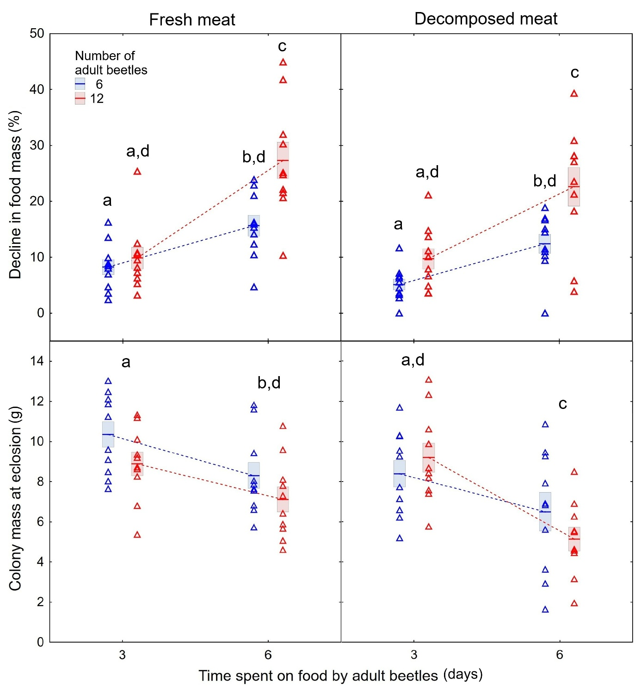
Fig. 1. Decline in food mass at the end of the adult beetle phase and colony mass at eclosion for laboratory colonies of Necrodes littoralis, which differed in the number of adult beetles, the time they stayed on food and the quality of food. Lines – means, boxes – standard errors of means, triangles – raw data, different letters – significant differences in pairwise comparisons.

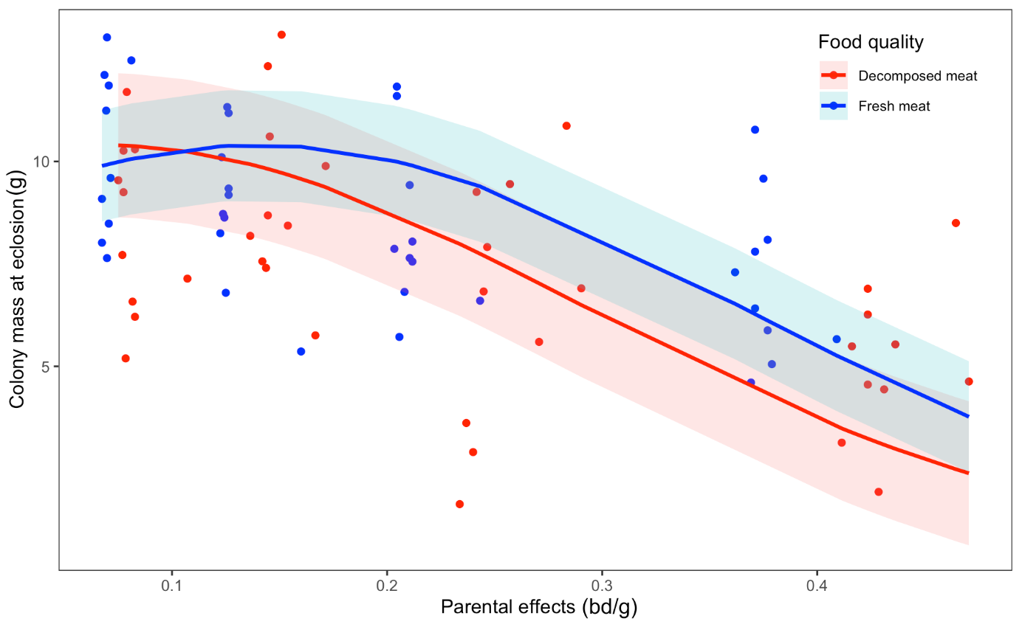
Fig. 2. The relationship between parental effects (in beetle-days per gram of food) and colony mass at eclosion for the ‘Decomposed’ and ‘Fresh’ meat treatments. Lines are exponential regression models, bands are 95% confidence intervals.

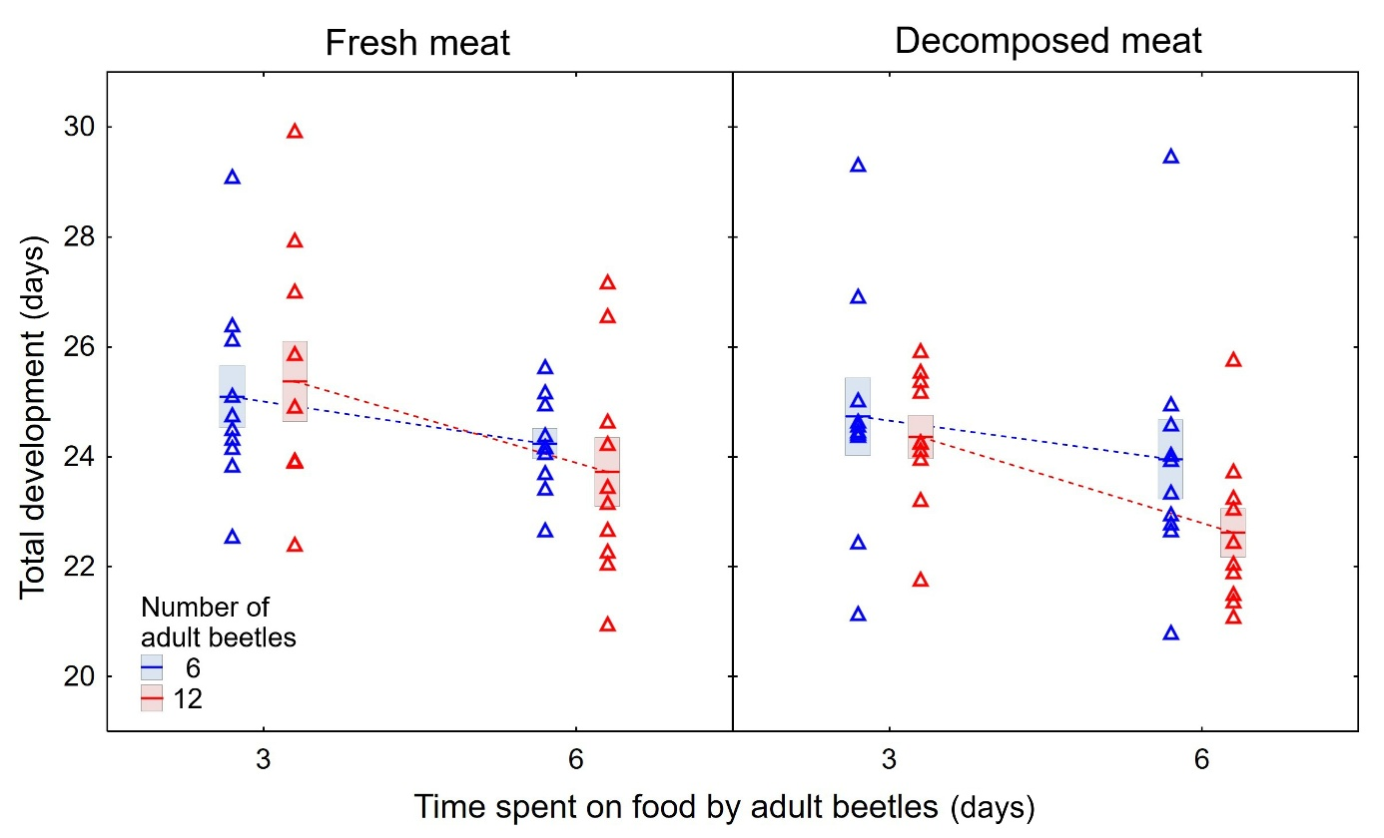
Fig. 3. Total development times for laboratory colonies of Necrodes littoralis, which differed in the number of adult beetles, the time they stayed on food and the quality of food. Lines – means, boxes – standard errors of means, triangles – raw data.

